Enhanced Financial Reporting System
Systems and User Manual
This Manual was prepared by AARC Ltd (Ireland)



Strengthening The Financial Management System in the Department of Education (Phase II)


April 2014

VOLUME II
Transaction Accounting Processes for eFRS
TABLE OF CONTENTS

1 Overview About This Manual 5
1.1 Background 5
1.2 eFRS User Manual 5
2 Establish Beginning Balances 7
2.1 Overview of Beginning Balance 7
2.2 Set Up Beginning Balance 7
2.3 Cash in Bank accounts 7
3 Bank Disbursement 9
3.1 Overview of Bank Disbursements 9
3.2 Check Disbursement 9
3.3 ADA Disbursement 13
3.4 Cancelled/Stale Checks 16
3.5 Fund Transfer 18
3.6 Bank Charges 19
4 Cash Disbursement 21
4.1 Overview of Cash Disbursements 21
4.2 Liquidations 21
4.3 Other transaction types 27
5 Cash Collection 28
5.1 Overview of Cash Collections 28
5.2 Refund of Cash Advance 31
5.3 Income of the National Government 31
5.4 Revolving Fund Receipts 32
5.5 Trust Receipts 33
5.6 Refund for Overpayment of Expenses 34
5.7 Dishonored Checks 35
6 Bank Deposit 36
6.1 Overview of Bank Deposits 36
6.2 Deposits of Collections 38
6.3 Trust Fund 39
6.4 Adjustment to Bank Deposits 39
7 Other Transactions 40
7.1 Overview of Other Transactions 40
7.2 NCA/NTA Receipt 40
7.3 Remittances to BIR 43
7.4 Non-Cash Expenses 46
7.5 General Corrections/Adjustments 49
7.6 NCA/NTA Lapsing 51
7.7 Year-end Closing 52
8 SU’s MOOE Liquidation 54
8.1 Overview of MOOE Liquidation 54
8.2 Accounting Entries 55
9 Frequently Asked Questions 58

LIST OF ABBREVIATIONS

ACIC | Advice of Check Issued and Cancelled
ADA | Automatic Debit Account
AGDB | Authorized government depository bank
AGSB | Authorized government servicing bank
ANCAI | Advice of Notice of Cash Allocation Issued
ATM | Automatic Teller Machine
BIR | Bureau of Internal Revenue
BRS | Bank Reconciliation Statement
BS | Balance Sheet
BTr | Bureau of Treasury
CO | Central Office
COA | Commission on Audit
DBM | Department of Budget and Management
DBP | Development Bank of the Philippines
DepED | Department of Education
DOF | Department of Finance
DO | Division Office
DS | Deposit Slip
DV | Disbursement Voucher
eFRS | Enhanced FRS
EFT | Electronic fund transfer
FRS | Financial Reporting System
GAA | General Appropriations Act
GIFMIS | Government Integrated Financial Management Information System
GSIS | Government Service Insurance System
IU | Implementing Unit
JEV | Journal Entry Voucher
LBP | Land Bank of the Philippines
LDDAP | List of Due and Demandable Accounts Payable
LLOU | Lowel level operating unit
LR | Liquidation Report
MDS | Modified Disbursement System
MFO | Major Final Output
MOOE | Maintenance and Other Operating Expense
NCA | Notice of Cash Allocation
NEAP | National Educators Academy of the Philippines
NG | National Government
NGA | National Government Agency
NGAS | New Government Accounting System
NSTIC | National Science Teaching Instrumentation Center
NTA | Notice of Transfer of Allocation
OBr | Obligation Request
OR | Official Receipt
PAP | Program, Activity, Project
PCF | Petty Cash Fund
PERA | Personnel Economic Relief Allowance
PS | Personal Services
PVB | Philippine Veterans Bank
RA | Regular Agency
RCD | Report of Collection and Deposit
RCI | Report of Check Issued
RD | Report of Disbursement
RELC | Regional Education Learning Center
RO | Regional Office
SU | Spending Unit
Sub-ARO | Sub-Allotment Release Order
TRA | Tax Remittance Advice
UACS | Unified Account Code Structure

Overview About This Manual

Background
For clarifications and queries, you may contact the Project on:

Mobile:
09166598811
Landline:
(02)-6335397
email:
deped.gifmis@gmail.com
The Enhanced Financial Reporting System (eFRS) originated from the basic Financial Reporting System (FRS) used by some accounting units in the Department of Education (DepED). It was initiated by a field office in Region 9 a few years back and its development was then continued by Mr. Harold Magadia, a programmer in the Accounting Division of DepEd Central Office, up until its latest version. The current version of eFRS is 3.0 or the eFRS V3.0. Hence, all eFRS term used in this manual refers to eFRS V3.0.
The principal developer of eFRS is Mr. Magadia himself together with the guidance and supervision of the Accountants from DepED Central Office. Feedbacks from field offices were also incorporated in the system along with the recommendations and suggestions pointed out by the consulting team. The main distinction of eFRS as compared to its predecessors is that it is already Unified Account Code Structure (UACS) compliant. This means that it can already cater the 46-digit UACS code, as mandated through COA-DBM-DOF Joint Circular No. 2013-1, in recording financial transaction. In addition, the eFRS adheres to relevant rules and regulations as mandated by the Commission on Audit (COA) and the Department of Budget and Management (DBM), including strict compliance to pertinent guidelines and issuances deemed necessary by these oversight agencies.
The main purpose of eFRS is to provide relative ease in recording transactional data needed for accounting units as compared to the manual process or even with standard spreadsheets especially when coding the 46-digit UACS code. It was also designed to produce appropriate reports and export relevant financial data as needed. Generally, eFRS is designed to provide support for Accounting personnel in the meantime while the Government Integrated Financial Management Information System (GIFMIS) is still undergoing development. Until such time when GIFMIS will be fully implemented in DepED, eFRS will play a vital role in recording accounting entries and other financial data as well as generating reports and other financial statements.
The primary purpose of this manual is to provide a reference document for end users of the eFRS. It covers instructions, definitions, illustrations, step-by-step guide, descriptions, and explanations related to the functions of the system.

eFRS User Manual
For clarifications and queries, you may contact the Project on:

Mobile:
09166598811
Landline:
(02)-6335397
email:
deped.gifmis@gmail.com
Who should use the manual?
This manual is primarily designed for DepEd personnel from accounting units in different levels of the department tasked with maintaining Journal Entry Vouchers (JEV) and other financial documents such as general journals, ledgers, etc. It is also designed for use by accountants, bookkeepers, and other accounting staff for generating reports and extracting financial data.

What is eFRS?
eFRS stands for Enhanced Financial Reporting System. It is a system used by the DepED for recording various financial data and consequently generating reports as required by oversight agencies such as the COA and DBM.
Why do we need to use eFRS?
The current version of eFRS incorporates UACS as mandated by COA-DBM-DOF Joint Circular No. 2013-1 set out at Appendix 1. With the 46 digit format of UACS, DepEd realized the difficulty in properly coding each financial transaction to its appropriate UACS code. Although this would be addressed with the advent of GIFMIS, which will come in late 2015, there is still a gap of approximately 2 years from the implementation of UACS to that of GIFMIS. As such, there is a need to have a system to support DepEd during this gap. Hence, the adoption of the enhanced FRS.
What is the scope of eFRS?
The eFRS is designed to capture financial data as reflected in the JEVs including other supporting documents such as checks, disbursement vouchers, official receipts, etc. It basically record important details for check and cash disbursements, cash collections and deposits, general journal, and liquidations. For reporting, it can produce trial balance and financial statements.
What is covered in the manual?
The manual comes in two volumes. Volume I covers the following topics: system requirements, installation, setup, data entry, search and editing of records, reports generation, and exporting data. It also includes frequently asked questions (FAQs) and how-tos related to eFRS operation. Volume II illustrates the data entry functions of the system. It focuses on the transaction accounting processes.

Establish Beginning Balances

Overview of Beginning Balance
Balance Sheet accounts, comprising of Assets, Liabilities and Government Equity, are called real accounts, which normally have balances that are brought forward to the succeeding years. Cash – MDS accounts (Regular, Special Account, and/or Trust) however have no forwarding balances due to automatic lapsing of the Notice of Cash Allocation (NCA), an authority granted to DepEd’s operating units to disburse and issue Modified Disbursements System (MDS) checks, at specified time.
In setting up an opening balance for the balance sheet accounts, the eFRS provides menu and input fields to enter the beginning balances.

Set Up Beginning Balance
Using the Post-Closing Trial Balance or Detailed Balance Sheet (BS), input the account balances following the steps below:
- Select the Fund Source Code from the drop-down list in the appropriate fields. Please be reminded that data input is on a per Fund Source basis.
- Indicate None (000000000) in the MFO/PAP Code.
- Select the particular Object Codes from the drop-down list in the appropriate fields. Ensure that all New Government Accounting System (NGAS) Object Codes have been duly converted to the UACS.
- Enter the amounts of the beginning balances corresponding to every Object Code at statement date
- Click OK to post the transactions.
- Do the same steps for other Fund Source Codes, if any.

Cash in Bank accounts
Setting up of the beginning balances in the eFRS only accounts for the total or aggregate amount. Now, in order to maximize the use of information, most importantly on Cash in Bank – Local Currency, the details as to individual bank accounts should also be established. Such information is very significant in the preparation of the Bank Reconciliation Statement (BRS).
To set up the opening balance for each of the Cash in Bank – Local Currency bank account, the following steps shall be observed:
- Click the Bank Deposits transaction type.
- Set the JEV Number.
- Select the appropriate Fund Source Code from the drop-down list. Ensure that the fund source here matches with the code chosen in the System Setup when establishing the beginning balances.
- Put 0 (zero) in the Deposit Slip Number and Date for all entries.
- Select the appropriate bank account number and Object Code for the Cash in Bank – Local Currency account from the drop-down list for the debit items.
- Put 0 (zero) in the bank account number field and select the Object Code for the Cash in Bank – Local Currency account from the drop-down list for the credit item.
- Enter the corresponding amount for each of the beginning bank account balance in the debit side, and the total or aggregate amount in the credit side.
- Check whether total debit and credit amounts are in balance. Then click Post Transaction button.
The journal entry would appear as:
Transaction and Accounting Entries | Fund Source Code | MFO/PAP Code | Object Code | Debit | Credit
Cash in Bank – LCCA (Bank Account No. 1)  Cash in Bank – LCCA (Bank Account No. 2)  Cash in Bank – LCCA (Bank Account No. 3)  Cash in Bank – LCCA (Bank Account No. 4)  Cash in Bank – LCCA (Total per BS)  Record bank details for Cash in Bank – LCCA accounts | 101101  101101  101101  101101  101101 | 000000000  000000000  000000000  000000000  000000000 | 1010202016  1010202016  1010202024  1010202032  1010202000 | x,xxx.xx  x,xxx.xx  x,xxx.xx  x,xxx.xx | x,xxx.xx
The same principle applies to Cash in Bank – Local Currency, Saving Deposit and Cash in Bank – Foreign Currency, Savings Account, if any.

Bank Disbursement

Overview of Bank Disbursements
Bank Disbursement refers to the payment transactions involving DepEd’s bank accounts or financial transactions resulting to credits in the bank account balances. This transaction type includes the following, but not limited to:
- Check Disbursements
- Authority to Debit Account (ADA) or Notice of Transfer of Allocation (NTA) Disbursements
- Cancelled Checks and/or Stale Checks
- Lapsing of NCA and/or NTA
- Bank Charges

Check Disbursement
Check Disbursements are payments made to various creditors or payees through the use of paper checks. The two types of checks being issued by DepEd are the MDS Check and Commercial Checks. MDS Checks are issued by government agencies, such as DepEd, chargeable against the account of the Bureau of Treasury (BTr) which is maintained in various authorized government servicing banks (AGSB). These are covered by Notice of Cash Allocation (NCA), an authorization issued by the DBM to government agencies to withdraw cash from the National Treasury through the issuance of MDS checks. Commercial Checks are issued by DepEd against its non-MDS bank accounts, such as Revolving Funds and Trust Receipts.
The necessary reference documents to support the recording of check disbursement transactions are the following:
- Copy of check issued
- Disbursement Voucher (DV)
- Obligation Request (OBr)
- Reference issued check may also be required for the Petty Cash Fund (PCF) replenishments and other similar transactions.

To record the transaction in the eFRS, the following steps shall be observed:

- Set the JEV Number by choosing the appropriate year and month of the transaction, then the transaction date.

- Click and select the transaction category, “Bank Disbursements”, from the dropdown list. Make sure to click the same “Bank Disbursements” button for the correct form of entry fields to appear.
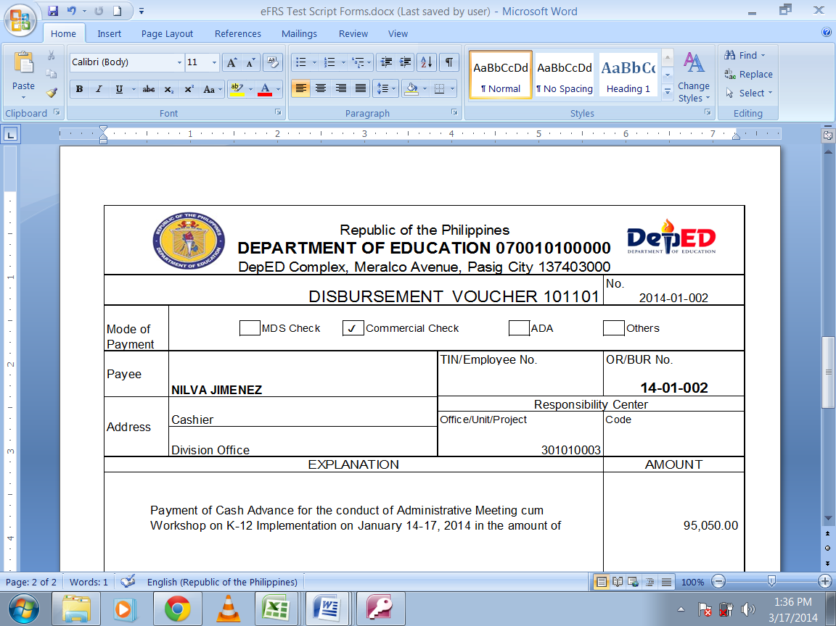
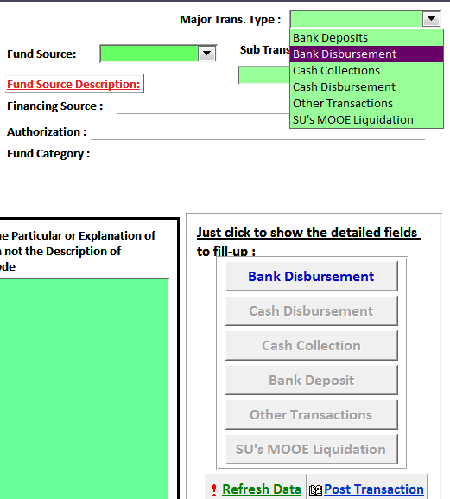

- Click and select the sub-transaction type, “Check Disbursements”, and choose the appropriate Fund Source Code from the dropdown lists.

- Input all required data from the DV to the entry form. Remember, don’t leave any field blank!

- Complete the accounting entries: click and select appropriate MFO/PAP and Object Codes from the dropdown lists and enter into the corresponding debit and credit amounts. Note that the MFO/PAP Codes must be specified for Expense account, such as PS, MOOE, Financial Expenses (if any) and Capital Outlays codes. Otherwise, choose nine zeroes or None as MFO/PAP Code.

- Verify the debit and credit entries before clicking the “Post Transaction” button. Descriptions for each entry level are reflected at the bottom of the display page. Make sure that the balance checker shows zero amounts and no ERRORS.

- When necessary, print the JEV and file on top of the transaction documentation.

eFRS required Input Fields
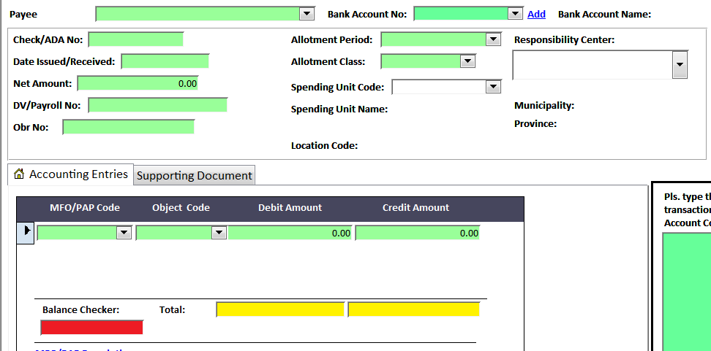
Required information from supporting documents, such as DV.
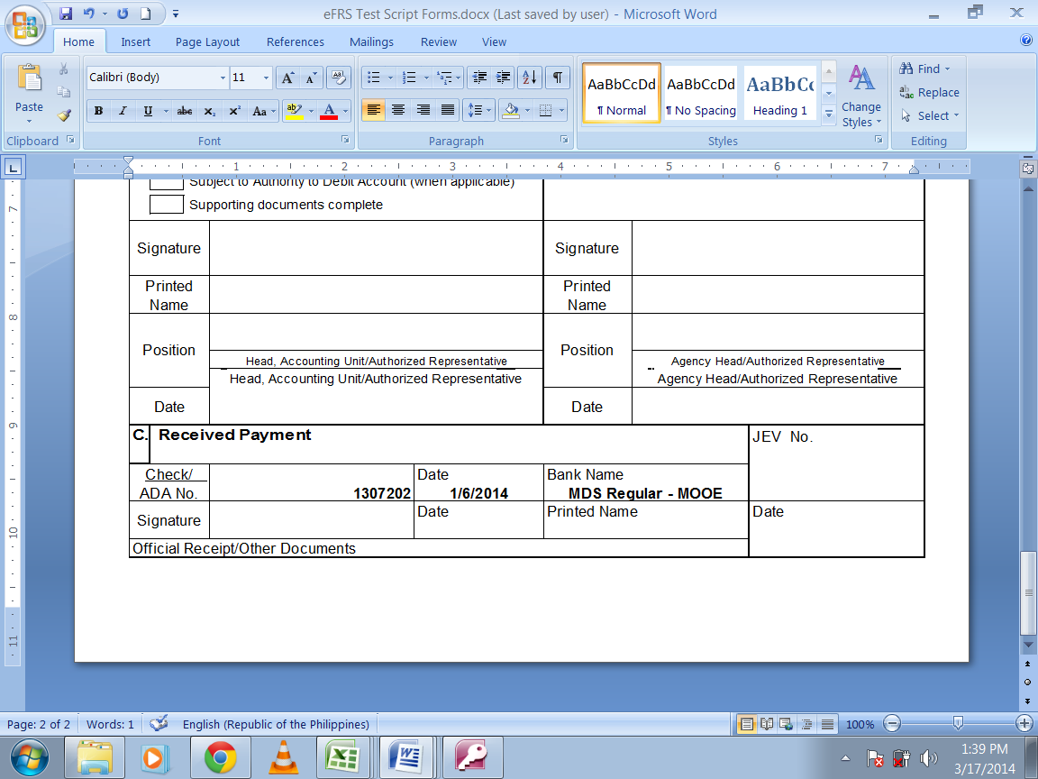
The common transactions under this transaction type include grant of Cash Advances for travel, payroll or MOOEs, establishment and replenishments of PCF, and payment to suppliers or creditors. Illustrative accounting entries for some related transactions are as follows:

Transaction and Accounting Entries | Fund Source Code | MFO/PAP Code | Object Code | Debit | Credit
Petty Cash Fund  Cash – MDS, Regular  Establishment of PCF | 101101  101101 | 000000000  000000000 | 1010102000  1010404000 | x,xxx.xx | x,xxx.xx
Advances to Officers and Employees  Cash – MDS, Regular  Grant of cash advance for travel | 101101  101101 | 000000000  000000000 | 1990104000  1010404000 | x,xxx.xx | x,xxx.xx
Advances for Operating Expenses  Cash – MDS, Regular  Grant of cash advance for MOOEs | 101101  101101 | 000000000  000000000 | 1990101000  1010404000 | x,xxx.xx | x,xxx.xx
Advances to Special Disbursing Officer  Cash – MDS, Regular  Grant of cash advance for training | 101101  101101 | 000000000  000000000 | 1990103000  1010404000 | x,xxx.xx | x,xxx.xx
Advances for Payroll  Cash – MDS, Regular  Grant of cash advance for payroll | 101101  101101 | 000000000  000000000 | 1990102000  1010404000 | x,xxx.xx | x,xxx.xx
Due to GSIS – Life and Retirement Premium  Due to GSIS – ECC  Due to GSIS – Salary Loan  Due to GSIS – Policy Loan  Due to Pag-IBIG – Pag-IBIG Premium  Due to Pag-IBIG – Pag-IBIG Multi-Purpose Loan  Due to Pag-IBIG – Pag-IBIG Housing Loan  Due to PhilHealth  Other Payables  Cash – MDS, Regular  Remittance of salary deductions | 101101  101101  101101  101101  101101  101101  101101  101101  101101  101101 | 000000000  000000000  000000000  000000000  000000000  000000000  000000000  000000000  000000000  000000000 | 2020102001  2020102002  2020102003  2020102004  2020103001  2020103002  2020103003  2020104000  2999999000  1010404000 | x,xxx.xx  x,xxx.xx  x,xxx.xx  x,xxx.xx  x,xxx.xx  x,xxx.xx  x,xxx.xx  x,xxx.xx  x,xxx.xx | x,xxx.xx
Retirement and Life Insurance Premiums  Cash – MDS, Regular  Remittance of government share | 104102  104102 | 302050002  000000000 | 5010301000  1010404000 | x,xxx.xx | x,xxx.xx
Pag-IBIG Contributions  PhilHealth Contributions  Employees Compensation Insurance Premiums  Cash – MDS, Regular  Remittance of government share* | 101101  101101  101101  101101 | 302050003  302050003  302050003  000000000 | 5010302000  5010303000  5010304000  1010404000 | x,xxx.xx  x,xxx.xx  x,xxx.xx | x,xxx.xx
Electricity Expenses  Cash – MDS, Regular  Payment of MERALCO bill | 101101  101101 | 100010000  000000000 | 5020402000  1010404000 | x,xxx.xx | x,xxx.xx
Telephone Expenses  Internet Subscription Expenses  Cash – MDS, Regular  Payment of PLDT bill | 101101  101101  101101 | 100010000  100010000  000000000 | 5020502000  5020503000  1010404000 | x,xxx.xx  x,xxx.xx | x,xxx.xx
Office Supplies Expenses  Postage and Courier Services  Cash – MDS, Regular  Replenishment of PCF | 101101  101101  101101 | 100010000  100010000  000000000 | 5020301000  5020501000  1010404000 | x,xxx.xx  x,xxx.xx | x,xxx.xx
Due from NGAs  Cash – MDS, Regular  Advance payment to DBM Procurement Service | 101101  101101 | 000000000  000000000 | 1030301000  1010404000 | x,xxx.xx | x,xxx.xx
Construction in Progress – Buildings & Other Structures  Advances to Contractors  Due to BIR  Other Payables  Cash – MDS, Regular  Progress payments | 101101  101101  101101  101101  101101 | 302020008  000000000  000000000  000000000  000000000 | 1061003000  1990201000  2020101000  2999999000  1010404000 | x,xxx.xx | x,xxx.xx  x,xxx.xx  x,xxx.xx  x,xxx.xx
*comes in different supporting documents: OBr, DV, etc.

ADA Disbursement
Disbursements through the Authority to Debit Account (ADA) are settlements of liabilities using the electronic fund transfer (EFT) authorized by the government agencies. ADA is issued in lieu of paper checks. It may be issued by the DBM to settle liabilities listed in the List of Due and Demandable Accounts Payable (LDDAP) submitted by DepEd. It may also be issued by DepEd itself against its MDS bank accounts.
The necessary reference documents to support the recording of bank disbursement transactions are the following:
- Bank-validated ADA
- DV
- OBr

To record the transaction in the eFRS, follow the steps observed in the check disbursements above, except for the transaction sub-type. Click and select the sub-transaction type, “ADA Disbursements”, and fill out the form using the data from the supporting documents and the dropdown lists.
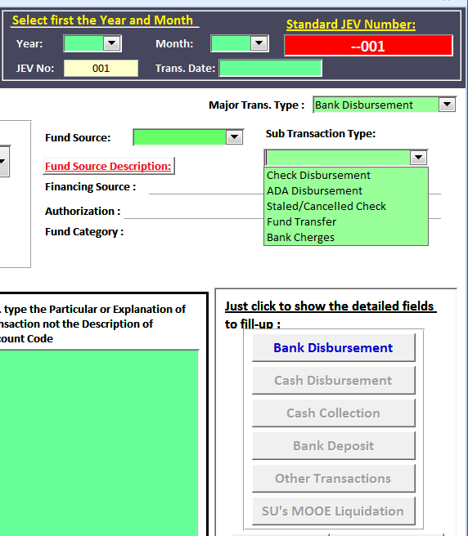
Other than the regular salaries paid through ATM Payroll System, ADA is usually issued to settle outstanding liabilities, while NTA is for subsidies to operating units. Illustrative accounting entries for some related transactions are as follows:
Transaction and Accounting Entries | Fund Source Code | MFO/PAP Code | Object Code | Debit | Credit
Accounts Payable  Cash – MDS, Regular  Due to BIR  Payment of Accounts Payable | 102101  102101  102101 | 000000000  000000000  000000000 | 2010101000  1010404000  2020101000 | x,xxx.xx | x,xxx.xx  x,xxx.xx
Prepaid Rent  Cash – MDS, Regular  Payment of 1-year office rentals | 101101  101101 | 000000000  000000000 | 1990101000  1010404000 | x,xxx.xx | x,xxx.xx
Construction in Progress – Buildings & Other Structures  Advances to Contractors  Due to BIR  Other Payables  Cash – MDS, Regular  Progress payments | 101101  101101  101101  101101  101101 | 302020008  000000000  000000000  000000000  000000000 | 1061003000  1990201000  2020101000  2999999000  1010404000 | x,xxx.xx | x,xxx.xx  x,xxx.xx  x,xxx.xx  x,xxx.xx
In case of payment of salaries and other PS items though, primarily for DOs which maintains the payroll for Teachers, the following extra steps must be observed:

- The Organization Codes of Spending Units must be considered and reflected in each JEV.
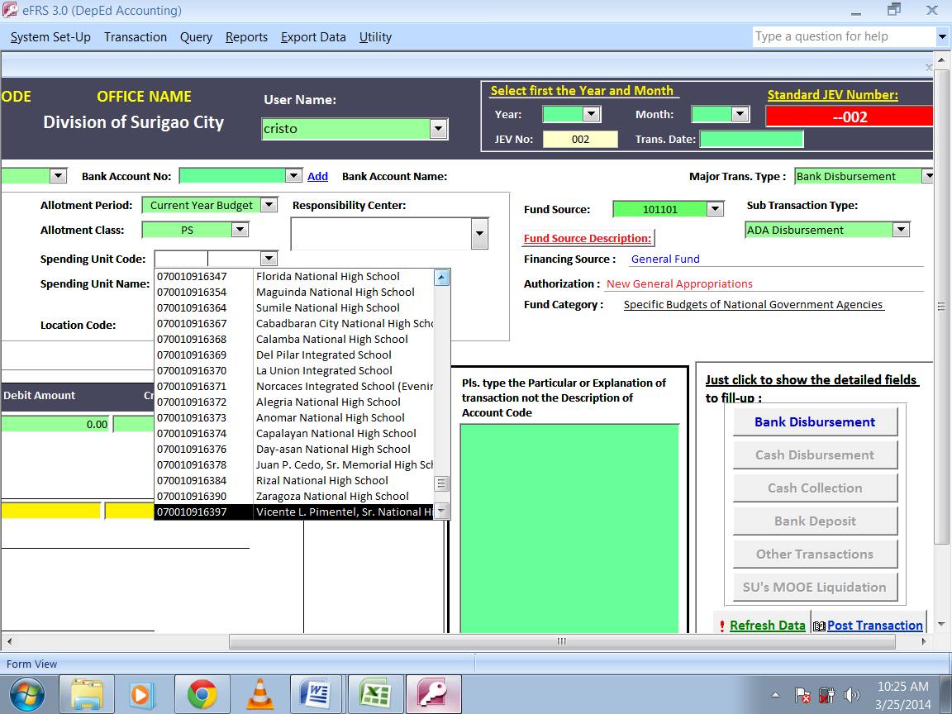

- Prepare 1 JEV for each Spending Unit (only for Secondary Schools) with own Organization Code. This is an example of transactions with several JEVs for 1 DV or Payroll.
- Supply all JEV details, then click and select the Spending Unit’s Organization Code from the dropdown list.
- Click and select the appropriate MFO/PAP Code for “MFO2: Operation of Schools – Secondary Schools”, i.e. 302050003, from the dropdown list in the Accounting entries section for every PS expense item.
- Verify the debit and credit entries before clicking the “Post Transaction” button. Descriptions for each entry level are reflected at the bottom of the display page. Make sure that the balance checker shows zero amounts and no ERRORS.
- When necessary, print the JEV and file on top of the transaction documentation.

- The MFO/PAP Codes for Operation of Kindergarten and Elementary Schools must be considered and appropriately indicated in each JEV.
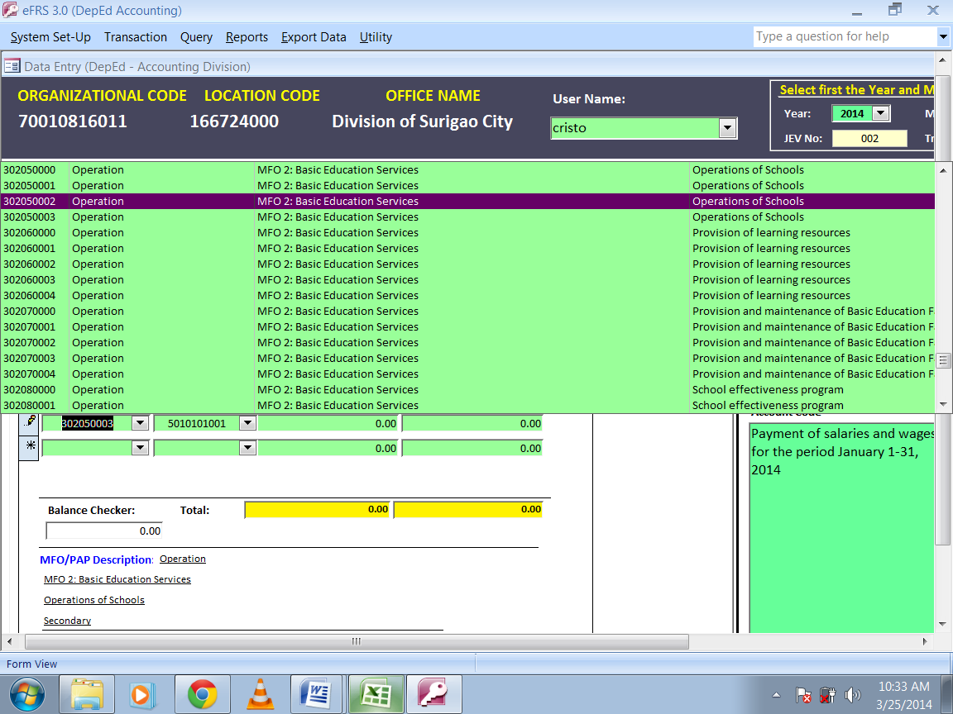

- Supply all JEV details, then click and select the DO’s Organization Code from the dropdown list. You may prepare 1 JEV for each school level, Kindergarten, Elementary, and Secondary (for schools directly maintained by the DO and do not have assigned Organization Codes).
- Click and select the appropriate MFO/PAP Code for “MFO2: Operation of Schools - Kindergarten”, “MFO2: Operation of Schools - Elementary”, or “MFO2: Operation of Schools - Secondary”, from the dropdown list in the Accounting entries section for every PS expense item.
- Verify the debit and credit entries before clicking the “Post Transaction” button. Descriptions for each entry level are reflected at the bottom of the display page. Make sure that the balance checker shows zero amounts and no ERRORS.
- When necessary, print the JEV and file on top of the transaction documentation.

Cancelled/Stale Checks
Cancelled checks are paper checks used but cancelled due to various reasons. Cancellation within the reporting month usually results from typographical errors, while those cancellations after the reporting month may result to unmatched check details between Advice of Check Issued and Cancelled (ACIC) and the issued check, error in the basis of computation, there is change in some details, or the check becomes stale. Check becomes stale when it has been outstanding for over six (6) months from the date of issuance or as prescribed.
The necessary reference documents to support the recording of bank disbursement transactions are the following:
- Reference issued and cancelled check
- Original DV
- Original OBr
- Bank Reconciliation Statement
Stale checks as well as checks cancelled after the reporting month shall require necessary adjusting entries. The illustrative accounting entries for some related transactions are as follows:
Transaction and Accounting Entries | Fund Source Code | MFO/PAP Code | Object Code | Debit | Credit
Cash – MDS, Regular  Travelling Expense - Local  Check cancellation after the reporting month | 101101  101101 | 000000000  000000000 | 1010404000  5020101000 | x,xxx.xx | x,xxx.xx
Cash – MDS, Regular  Accounts Payable  Stale check | 101101  101101 | 000000000  000000000 | 1010404000  2010101000 | x,xxx.xx | x,xxx.xx

To record the transaction in the eFRS, observe the following steps:

- After setting the JEV Number, click and select the sub-transaction type, “Stale/Cancelled Checks”, and fill out the form using the data from the supporting documents and the dropdown lists.

- Input all required data from the DV to the entry form. Input in the “Net Amount” field a negative entry equal to the amount of stale check or check to cancel.
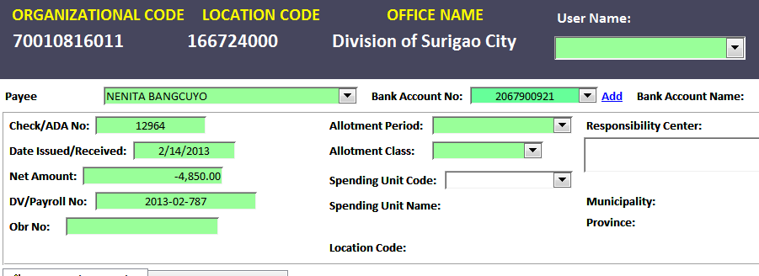

Sample cancelled check

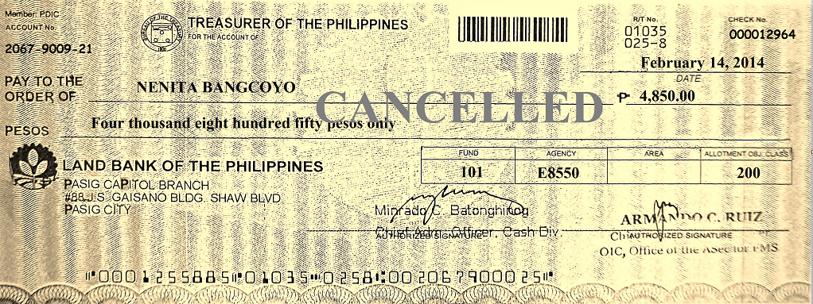

- Complete the reversing accounting entries: click and select appropriate MFO/PAP and Object Codes from the dropdown lists and enter into the corresponding debit and credit amounts.
- Verify the debit and credit entries before clicking the “Post Transaction” button. Descriptions for each entry level are reflected at the bottom of the display page. Make sure that the balance checker shows zero amounts and no ERRORS.
- When necessary, print the JEV and file on top of the transaction documentation.

Fund Transfer
Disbursement through issuance of the Notice of Transfer of Allocation (NTA) is a scheme whereby DepEd instructs the AGSB to transfer a specific amount out of its NCA available balance to the bank accounts of the receiving agencies, e. g. ROs, DOs, and/or IUs.
The necessary reference documents to support the recording of bank disbursement transactions are the following:
- Bank-validated NTA
- DV
- OBr

To record the transaction in the eFRS, follow the steps observed in the check disbursements above, except for the transaction sub-type. Click and select the sub-transaction type, “Fund Transfer”, and fill out the form using the data from the supporting documents and the dropdown lists.

Bank Charges
This transaction type shall cover all the bank charges. The term bank charge covers all charges and fees made by the AGSB against the cash in bank balance of the department.
The necessary reference documents to support the recording of bank disbursement transactions are the following:
- Bank Statement
- Bank Reconciliation Statement
The illustrative accounting entries for some related transactions are as follows:
Transaction and Accounting Entries | Fund Source Code | MFO/PAP Code | Object Code | Debit | Credit
Financial Assistance to NGAs  Cash – MDS, Regular  Issuance of NTA to ROs | 101101  101101 | 200130000  000000000 | 5021402000  1010404000 | x,xxx.xx | x,xxx.xx
Bank Charges  Cash – MDS, Regular  Issuance of NTA to ROs | 101101  101101 | 100010000  000000000 | 5030104000  1010404000 | x,xxx.xx | x,xxx.xx

To record the transaction using the eFRS, the following steps must be observed:

- After setting the JEV Number, click and select the sub-transaction type, “Bank Charges”, and fill out the form using the data from the supporting documents and the dropdown lists.

- Put zeroes in input fields where information is not available.
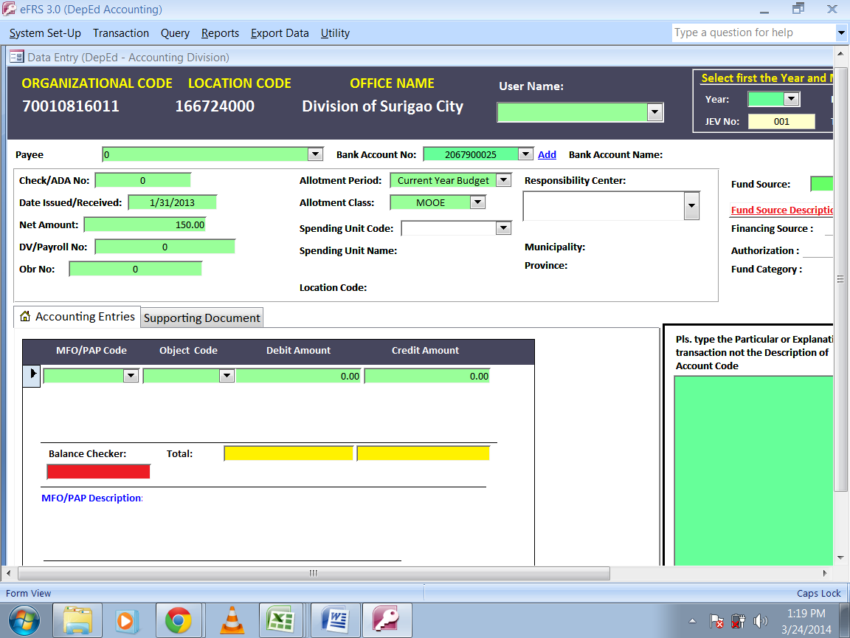

Cash Disbursement

Overview of Cash Disbursements
Cash Disbursement refers to payments made through cash. Most often, this transaction type covers all liquidations of Cash Advances granted, such as, but not limited to the:
- Liquidation of Advances for Payroll
- Liquidation of Cash Advances for Travels
- Final liquidation of PCF for the calendar year
- Liquidation of Cash Advances for Maintenance and Other Operating Expenses (MOOE) by the Spending Units (SU)
- Cash payments out of collections during the conduct of trainings

Liquidations
Disbursements by cash shall be made from cash advances drawn and maintained in accordance with COA rules and regulations. All cash advances, for payroll, MOOE, travel and petty cash fund, are subject to liquidation, pursuant to COA Accounting Circular 2006-001 dated November 9, 2006.
Payroll Fund
Cash advances granted to disbursing officers for the salaries and wages of officers and employees and other personnel benefits shall be classified separately from other cash advances given to disbursing officers. Advances for Payroll shall be liquidated within five (5) days after the pay period.
To record the payroll liquidation, the following documents shall support the expenditures:
- Report of Disbursement
- Payroll
- Original OBr
- Reference issued check

Using the eFRS, the following steps must be observed:

- Set the JEV Number by choosing the appropriate year and month of the transaction, then the transaction date.

- Click and select the transaction category, “Cash Disbursements”, from the dropdown list. Make sure to click the same “Cash Disbursements” button for the correct form of entry fields to appear.

- Click and select the sub-transaction type, “Cash Advance Payroll”, and choose the appropriate Fund Source Code from the dropdown lists.

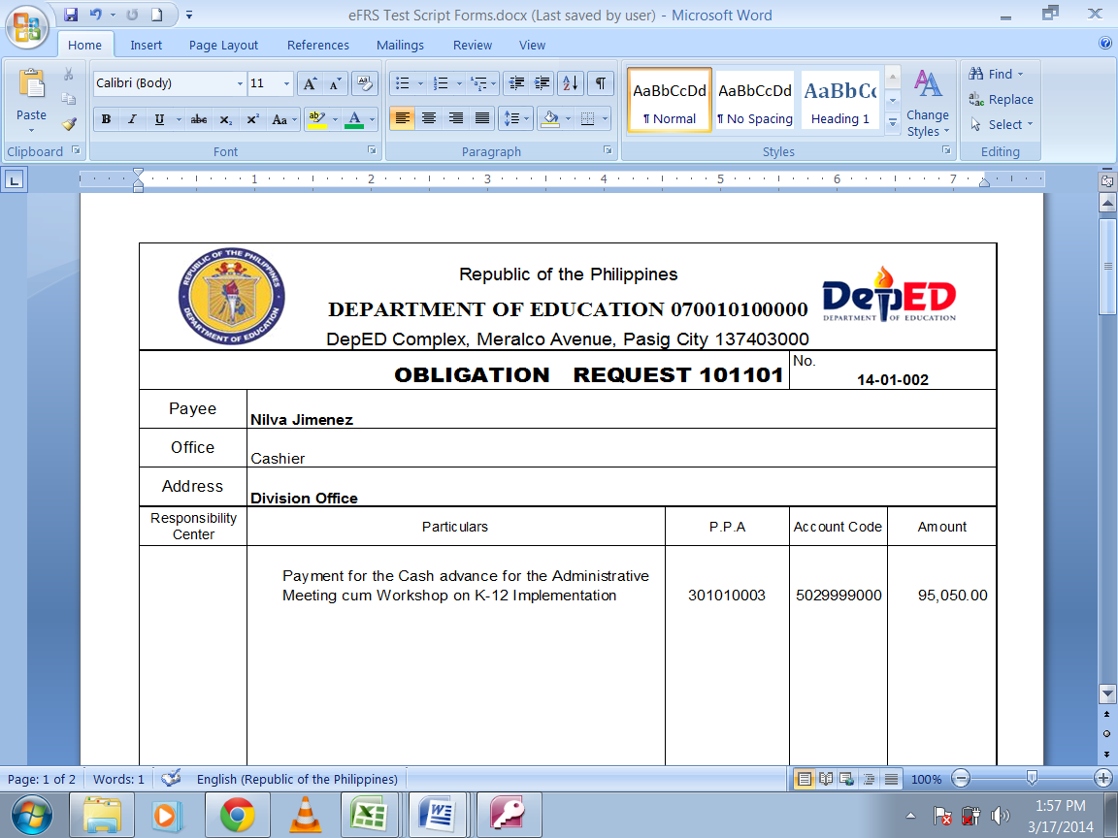
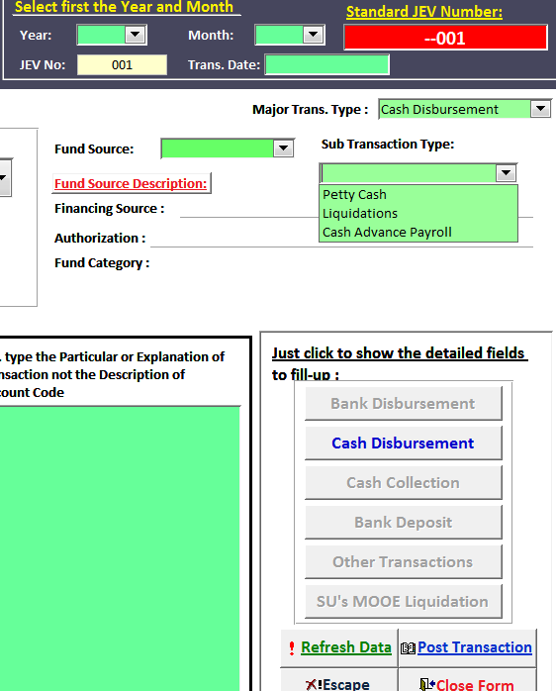
Reference OBr

- Input all required data from the Report of Disbursement (RD) to the entry form. Don’t leave any field blank! Make sure that the RD/LR contains all important information found in the DV and OBr; otherwise they must form part of the supporting documents.

- Complete the accounting entries: click and select appropriate MFO/PAP and Object Codes from the dropdown lists and enter into the corresponding debit and credit amounts.

It is during liquidation of cash advances that expenses are recognized. Note that the MFO/PAP Codes must be specified for Expense account, such as PS, MOOE, Financial Expenses (if any) and Capital Outlays codes. Take the MFO/PAP Codes from the original and signed OBr form. Choose nine zeroes or None as MFO/PAP Code for non-expense entries.

- Verify the debit and credit entries before clicking the “Post Transaction” button. Descriptions for each entry level are reflected at the bottom of the display page. Make sure that the balance checker shows zero amounts and no ERRORS.

- When necessary, print the JEV and file on top of the transaction documentation.

eFRS Input Fields
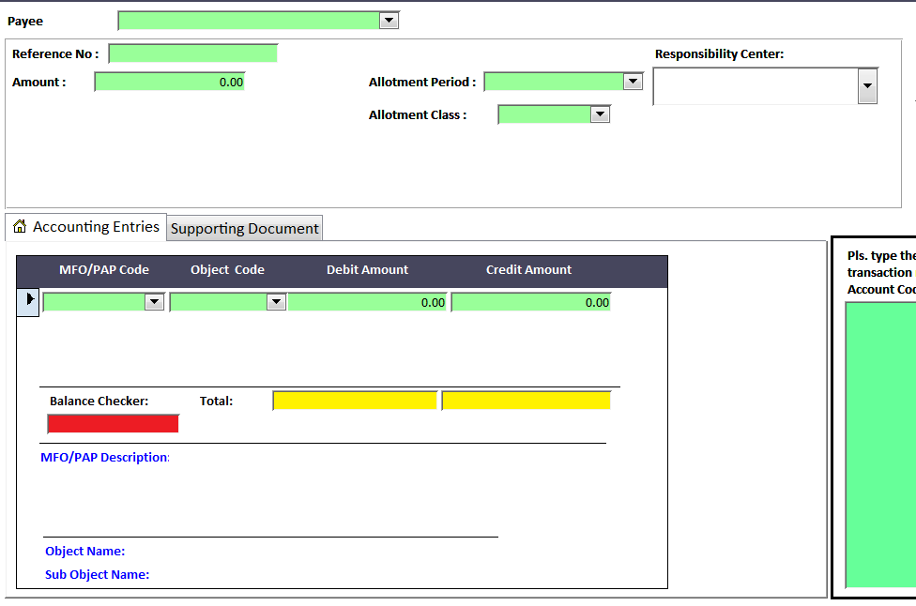
MFO/PAP Code
Required information from supporting documents, such as RD.
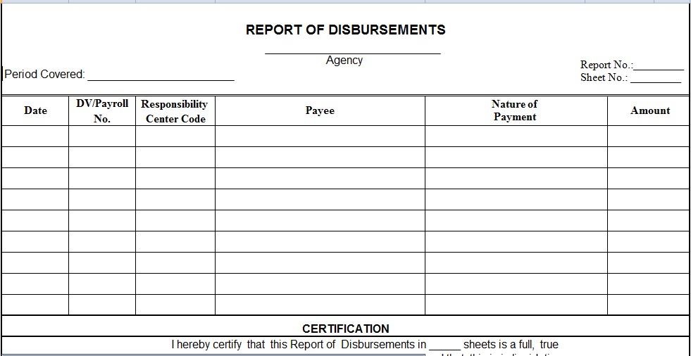

The illustrative accounting entries for some related transactions are as follows:
Transaction and Accounting Entries | Fund Source Code | MFO/PAP Code | Object Code | Debit | Credit
Salaries and Wages - Regular  Salaries and Wages - Regular  Salaries and Wages - Regular  Salaries and Wages - Regular  PERA  PERA  Advances for Payroll  Due to BIR  Due to GSIS-Life & Retirement Premium  Due to GSIS-Salary Loan  Due to GSIS-Policy Loan  Due to Pag-IBIG-Premium  Due to Pag-IBIG-Multipurpose Loan  Due to Pag-IBIG-Housing Loan  Due to PhilHealth  Other Payables  Payroll liquidation | 101101  101101  101101  101101  101101  101101  101101  101101  101101  101101  101101  101101  101101  101101  101101  101101 | 100010000  302050001  302050002  302050003  100010000  302050001  000000000  000000000  000000000  000000000  000000000  000000000  000000000  000000000  000000000  000000000 | 5010101001  5010101001  5010101001  5010101001  5010201000  5010201000  1990102000  2020101000  2020102001  2020102003  2020102004  2020103001  2020103002  2020103003  2020104000  2999999000 | x,xxx.xx  x,xxx.xx  x,xxx.xx  x,xxx.xx  x,xxx.xx  x,xxx.xx | x,xxx.xx  x,xxx.xx  x,xxx.xx  x,xxx.xx  x,xxx.xx  x,xxx.xx  x,xxx.xx  x,xxx.xx  x,xxx.xx  x,xxx.xx
Cash Advance for Travel
Cash advances granted for travel shall be accounted for as "Advances to Officers and Employees" to establish the accountability of the recipient. This shall be liquidated or settled immediately upon travel completion, evidenced by complete Liquidation Report and travel documents.
Cash Advance for Special Purpose
Cash advances granted for special time-bound undertaking shall be accounted for as "Advances to Special Disbursing Officer" to establish the accountability of the recipient. It includes advances to defray training expenses and labor payroll for projects undertaken by administration. This shall be liquidated or settled immediately after the completion of the undertaking for which it was granted, evidenced by complete Liquidation Report and documents supporting the activity.
Advances for Operating Expenses
Cash advances granted by higher office to their respective lower level operating units (LLOU) covering budgetary releases for current operating expenses shall be accounted for as "Advances for Operating Expenses" by the releasing agency. This shall be liquidated or settled before the subsequently advances will be granted.
To record the liquidation of cash advances for travel, special purpose, and operating expenses, the following documents shall support the expenditures:
- Liquidation Disbursement
- Original DV
- Original OBr
- Reference issued check
To record the transaction in the eFRS, follow the steps observed in the Liquidation of Cash Advance Payroll above, except for the transaction sub-type. Click and select the sub-transaction type, “Liquidations”, and fill out the form using the data from the supporting Liquidation Report and the lists in the dropdown buttons.
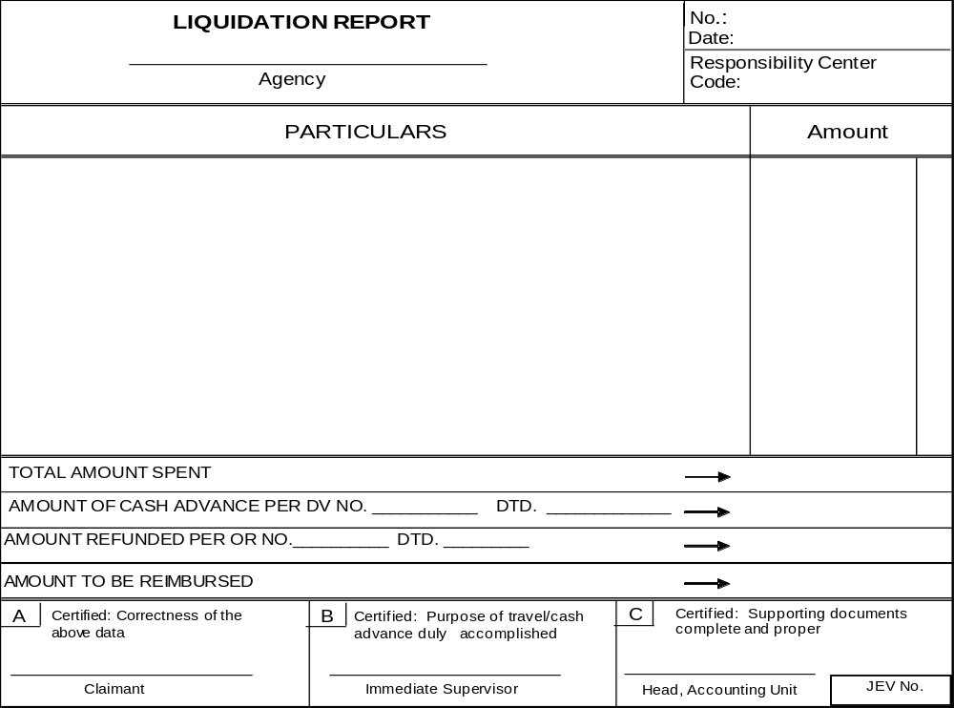
Transaction and Accounting Entries | Fund Source Code | MFO/PAP Code | Object Code | Debit | Credit
Salaries and Wages - Regular  Salaries and Wages - Regular  Salaries and Wages - Regular  Salaries and Wages - Regular  PERA  PERA  Advances for Payroll  Due to BIR  Due to GSIS-Life & Retirement Premium  Due to GSIS-Salary Loan  Due to GSIS-Policy Loan  Due to Pag-IBIG-Premium  Due to Pag-IBIG-Multipurpose Loan  Due to Pag-IBIG-Housing Loan  Due to PhilHealth  Other Payables  Payroll liquidation | 101101  101101  101101  101101  101101  101101  101101  101101  101101  101101  101101  101101  101101  101101  101101  101101 | 100010000  302050001  302050002  302050003  100010000  302050001  000000000  000000000  000000000  000000000  000000000  000000000  000000000  000000000  000000000  000000000 | 5010101001  5010101001  5010101001  5010101001  5010201000  5010201000  1990102000  2020101000  2020102001  2020102003  2020102004  2020103001  2020103002  2020103003  2020104000  2999999000 | x,xxx.xx  x,xxx.xx  x,xxx.xx  x,xxx.xx  x,xxx.xx  x,xxx.xx | x,xxx.xx  x,xxx.xx  x,xxx.xx  x,xxx.xx  x,xxx.xx  x,xxx.xx  x,xxx.xx  x,xxx.xx  x,xxx.xx  x,xxx.xx
Traveling Expense - Local  Due from Officers and Employees  Travel liquidation | 101101  101101 | 100010000  000000000 | 5020101000  1990104000 | x,xxx.xx | x,xxx.xx
Training Expense  Advances to Special Disbursing Officer  Training liquidation | 101101  101101 | 200080000  000000000 | 5020201000  1990103000 | x,xxx.xx | x,xxx.xx
Office Supplies Expenses  Electricity Expenses  Telephone Expenses  Janitorial Services  Security Services  Advances for Operating Expenses  LLOU MOOE liquidation | 101101  101101  101101  101101  101101  101101 | 302050002  302050002  302050002  302050002  302050002  000000000 | 5020301000  5020402000  5020502000  5021202000  5011203000  1990101000 | x,xxx.xx  x,xxx.xx  x,xxx.xx  x,xxx.xx  x,xxx.xx | x,xxx.xx
The illustrative accounting entries for some related transactions are as follows
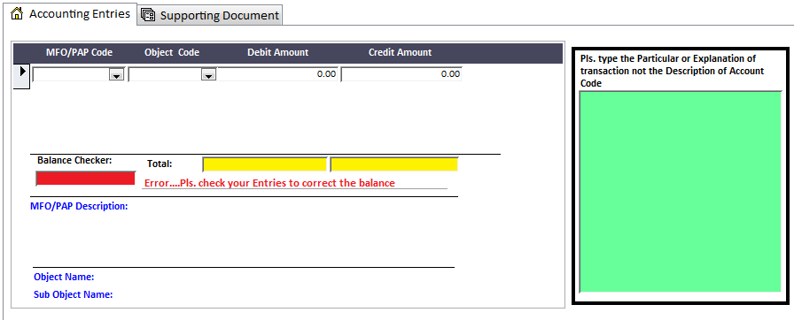

Other transaction types
Final Liquidation of Petty Cash Fund
Petty Cash Fund shall be maintained under the imprest system. As provided in Accounting Policies promulgated by COA, all replenishments shall be directly charged to the expense account and at all times, the Petty Cash Fund shall be equal to the total cash on hand and the unreplenished expenses. PCF final liquidation shall be accomplished within twenty (20) days after the end of the year.
To record the PCF final liquidation of the year, the following documents shall support the expenditures:
- Liquidation Disbursement
- Petty Cash Vouchers
- Original OBr
- Reference issued check
To record the transaction in the eFRS, follow the steps observed in the Liquidation of Cash Advance Payroll above, except for the transaction sub-type. Click and select the sub-transaction type, “Petty Cash”, and fill out the form using the data from the supporting Liquidation Report and the lists in the dropdown buttons.
The illustrative accounting entries for some related transactions are as follows:
Transaction and Accounting Entries | Fund Source Code | MFO/PAP Code | Object Code | Debit | Credit
Office Supplies Expenses  Fuel, Oil and Lubricants Expenses  Other Supplies and Materials Expenses  Petty Cash Fund  Liquidation of DO cash advance | 101101  101101  101101  101101 | 100010000  100010000  100010000  000000000 | 5020301000  5020309000  5020399000  1990101000 | x,xxx.xx  x,xxx.xx  x,xxx.xx | x,xxx.xx
Office Supplies Expenses  Fuel, Oil and Lubricants Expenses  Other Supplies and Materials Expenses  Petty Cash Fund  Liquidation of IU cash advance | 101101  101101  101101  101101 | 302050003  302050003  302050003  000000000 | 5020301000  5020309000  5020399000  1990101000 | x,xxx.xx  x,xxx.xx  x,xxx.xx | x,xxx.xx
Note that for the Liquidation of Cash Advances for Operating Expenses or the so-called MOOE Downloading subject to liquidation, the transaction category would be “SU’s MOOE Liquidation” which is a separate button. Refer to Section 11 below.

Cash Collection

Overview of Cash Collections
Cash collections refer to transactions involving receipts in the form of cash. For DepEd, this transaction type accounts for the receipts that comprise of, but not limited to, the following:
- Refund of excess advances
- Income of the National Government
- Revolving Funds
- Trust Receipts
- Bail, Bonds and/or Deposits
- Others, such as adjustments on disbursements for overpayment of expense and on collections for the Dishonored checks

To record the collections using the eFRS, the following steps must be observed:

- Set the JEV Number by choosing the appropriate year and month of the transaction, then the transaction date.

- Click and select the transaction category, “Cash Collections”, from the dropdown list. Make sure to click the same “Cash Collection” button for the correct form of entry fields to appear.

- There are two sub-transaction types for collections, RA and NG Receipts. Click and select the appropriate sub-transaction type.

- Choose the appropriate Fund Source Code from the dropdown lists based on the code indicated in the Report of Collection and Deposit (RCD) or Official Receipt. The usual Fund Source Codes in the receipt of cash are described as follows:
  - 101101 – General Fund, Current Appropriations, Specific Budget for the Operating Unit. This code will be used to account for both NG and RA receipts of cash arising from transactions using the same Fund Source, such as refunds and income from services and/or business operations. This may also cover all trust receipts, which are treated as General Fund Trust Liabilities, unless otherwise specified.
  - 207500s – Revolving Funds. As identified in UACS Manual, all receipts from those operations shall be coded accordingly. More detailed discussions can be found in Section 9.4.
  - 308602 – Trust receipts deposited with the National Treasury other than the Inter-Agency Transferred Funds. These are receipts from other sources which are deposited with the National Treasury pursuant to Executive Order No. 338 for the fulfilment of some obligations. For DepED, the Provident Fund falls here and thus will be coded such.
  - 308603 – Trust Receipts deposited with Authorized Government Depository Bank (AGDB). These are receipts from other sources that should be deposited in the AGDB for the fulfilment of some obligations. All Trust Liabilities outside General Fund will then be coded such.

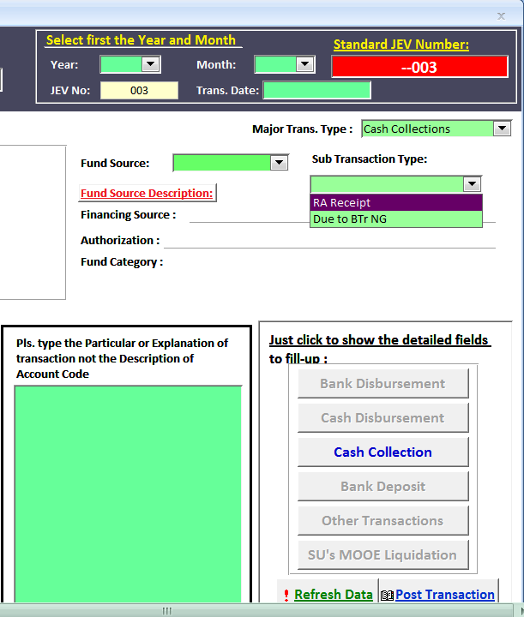

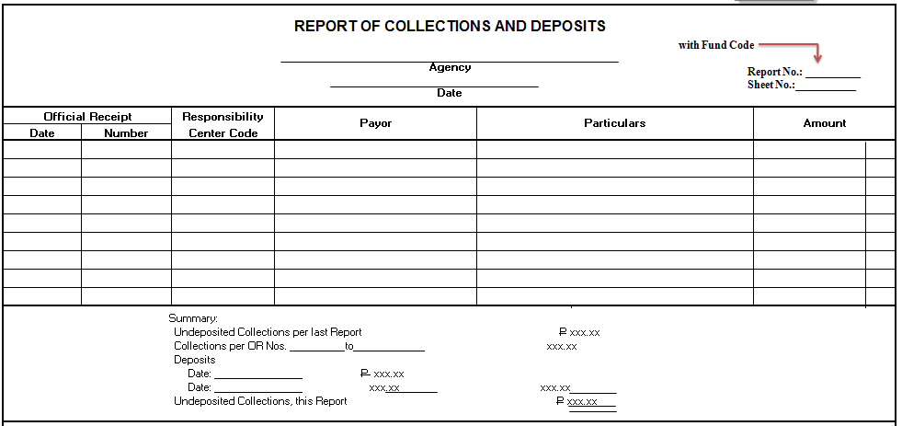

- After inputting the name of the Collecting Officer, complete the accounting entries. Note that the MFO/PAP Code is defaulted to None or 000000000. Input all required data from the RCD to the entry form, from OR details to credit amounts. For the debit entry, put zero (0) in OR Number and Payor columns, indicate the date based on the date prepared and signed by the Collection Officer, and type the total amount of collections at debit amount column. Don’t leave any field blank!

- Verify the debit and credit entries before clicking the “Post Transaction” button. Descriptions for each entry level are reflected at the bottom of the display page. Make sure that the balance checker shows zero amounts and no ERRORS.

- When necessary, print the JEV and file on top of the transaction documentation.

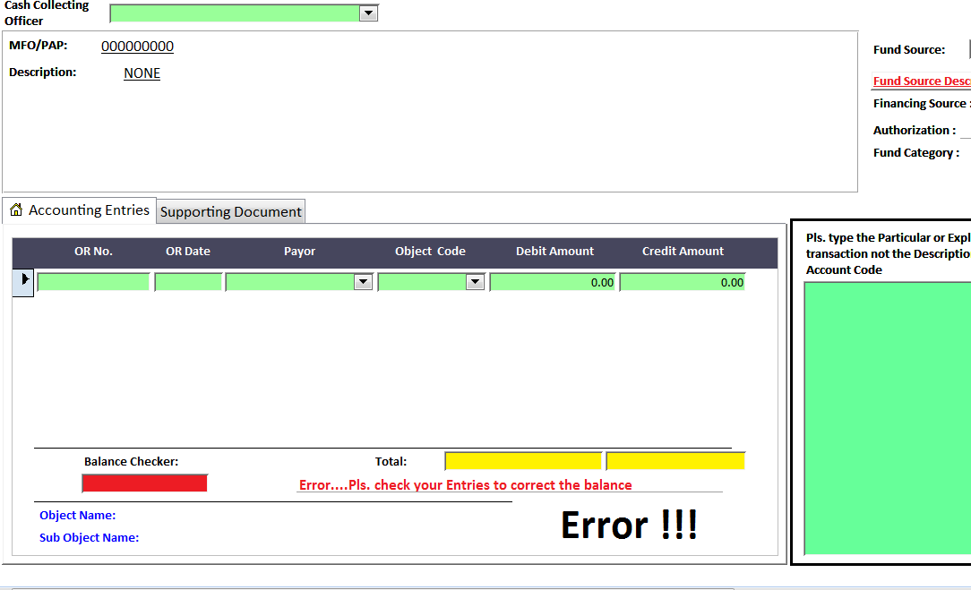

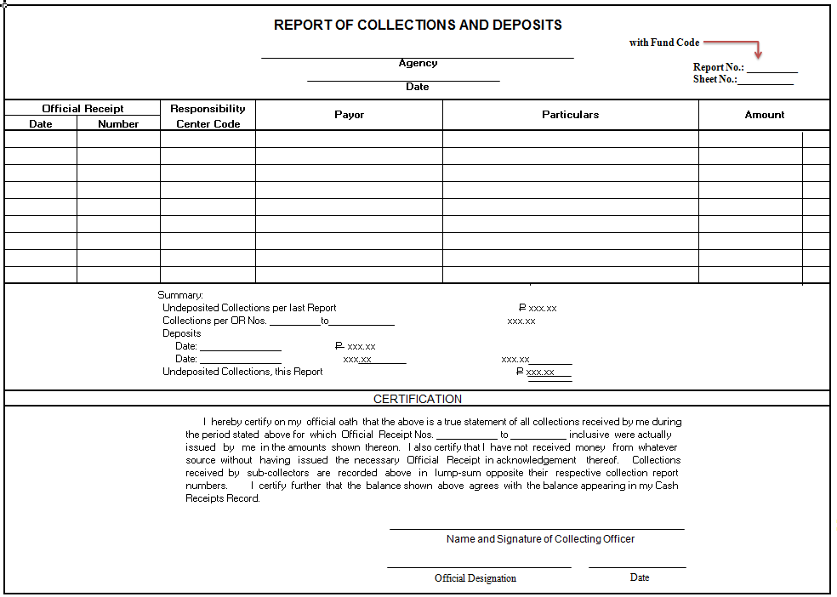

Refund of Cash Advance
When liquidation of cash advances for salaries and wages, travels, special purpose, or operating expenses amounted to less than the amount granted, the refunds thereof are made in cash, received and issued Official Receipt by the Collecting Officer.
To record the refunds, the following documents shall support the collection:
- Official Receipt/s
- Report of Collections and Deposits
- Reference issued check
The illustrative accounting entries for some related transactions are as follows:
Transaction and Accounting Entries | Fund Source Code | MFO/PAP Code | Object Code | Debit | Credit
Cash - Collecting Officer  Advances to Officers and Employees  Refund of excess cash advance for travel | 101101  101101 | 000000000  000000000 | 1010102000  1990104000 | x,xxx.xx | x,xxx.xx
Cash - Collecting Officer  Advances to Special Disbursing Officer  Refund of excess cash advance for training | 101101  101101 | 000000000  000000000 | 1010102000  1990103000 | x,xxx.xx | x,xxx.xx
Cash - Collecting Officer  Advances for Payroll  Refund of excess cash advance for salaries and wages | 101101  101101 | 000000000  000000000 | 1010102000  1990102000 | x,xxx.xx | x,xxx.xx
Cash - Collecting Officer  Advances for Operating Expenses  Refund of excess cash advance for SU’s MOOE | 101101  101101 | 000000000  000000000 | 1010102000  1990101000 | x,xxx.xx | x,xxx.xx

Income of the National Government
In as far as DepEd is concerned, the incomes of the National Government may comprise of the following business income accounts, among others:
- School Fees. Fees imposed to students of public schools, including tuition, registration, athletic, cultural, diploma and graduation, transcript of records, library, training, entrance examination fee, comprehensive examination fee, and the like.
- Seminar/Training Fees. Fees collected or billed for attendance in short course trainings and seminar/workshops.
- Rent/Lease Income. Income from use of government properties/facilities, such as rent/lease of function rooms/buildings
- Income from Hostels/Dormitories and Other Like Facilities. Fees/charges for the use of hostels, dormitories, cottages, guest houses, cafeterias, staff houses, lodging houses, and other similar facilities. If such income results from the DepEd’s business-type activities, it will then be considered a Revolving Fund, as described below.
- Income from Printing and Publication. Income from sale of printed forms, materials or other publications.
- Interest Income. Interest earned and/or actually collected on loans receivable, investments, bank deposits/financial assets and the like.
- Other Business Incomes
Cash collections arising from the above shall be received and issued Official Receipt, with Fund Source Code of 101101 (unless otherwise specified), by the Collecting Officer.
The following documents shall support the collection:
- Official Receipt/s
- Report of Collections and Deposits
The illustrative accounting entries for some related transactions are as follows:
Transaction and Accounting Entries | Fund Source Code | MFO/PAP Code | Object Code | Debit | Credit
Cash - Collecting Officer  School Fees  Seminar/Training Fees  Rent/Lease Income  Income from Hostels/Dormitories  Income from Printing and Publication  Interest Income  Other Business Income  Refund of excess cash advance for travel | 101101  101101  101101  101101  101101  101101  101101  101101 | 000000000  000000000  000000000  000000000  000000000  000000000  000000000  000000000 | 1010102000  4020201000  4020204000  4020205000  4020213000  4020215000  4020221000  4020299000 | x,xxx.xx | x,xxx.xx  x,xxx.xx  x,xxx.xx  x,xxx.xx  x,xxx.xx  x,xxx.xx  x,xxx.xx

Revolving Fund Receipts
Revolving Funds are receipts derived from business-type activities of DepEd as authorized by law, and which are deposited in an authorized government depository bank. These funds shall be self-liquidating. All obligations and expenditures incurred because of these business-type activities shall be charged against the Revolving Fund.
The list of authorized revolving funds for DepEd follows:
- Specific DepEd School
  - School Revolving Fund. Income earned from manufacturing and production programs, including auxiliary services of national schools. Fund Source Code is 207511
- Specific DepEd RO
  - RELC Revolving Fund. Registration Fees of Regional Education Learning Centers (B.P. 6831). Fund Source Code is 207512
  - Eco-Tech Center Revolving Fund. Income from seminars and conferences. Fund Source Code is 207513
  - Applied Nutrition Center Revolving Fund. Income from Dormitory Operations and Miscellaneous Income. Fund Source Code is 207514
  - Boracay National High School Hostel Revolving Fund. Income from Dormitory Operations, Miscellaneous Income. Fund Source Code is 207515
- OSEC - Baguio Teachers Camp Revolving Fund. Lodging Fees, Rental of Facilities, Interest Income (GAA). Fund Source Code is 207516
- National Educators Academy of the Philippines. (NEAP) Revolving Fund. Registration Fees, Use of Buildings, Interest Income (F 161). Fund Source Code is 207517
- National Science Teaching Instrumentation Center (NSTIC) Revolving Fund. Rental of Staff Houses. Fund Source Code is 207518
- National Museum Revolving Fund. Income from Museum operations (Republic Act 8492). Fund Source Code is 207519
Cash collections arising from the above shall be received and issued OR, with appropriate Fund Source Code, by the Collecting Officer.
The following documents shall support the collection:
- Official Receipt/s
- Report of Collections and Deposits
The illustrative accounting entries for some related transactions are as follows:
Transaction and Accounting Entries | Fund Source Code | MFO/PAP Code | Object Code | Debit | Credit
Cash - Collecting Officer  Registration Fees  Receipts from RELC Operations | 207512  207512 | 000000000  000000000 | 1010102000  4020102000 | x,xxx.xx | x,xxx.xx
Cash - Collecting Officer  Seminar/Training Fees  Receipts from Eco-tech Operations | 207513  207513 | 000000000  000000000 | 1010102000  4020204000 | x,xxx.xx | x,xxx.xx
Cash - Collecting Officer  Registration Fees  Rent/Lease Income  Interest Income  Receipts from NEAP Operations | 207517  207517  207517  207517 | 000000000  000000000  000000000  000000000 | 1010102000  4020102000  4020205000  4020221000 | x,xxx.xx | x,xxx.xx  x,xxx.xx  x,xxx.xx

Trust Receipts
Trust Receipts are receipts that are officially in the possession of government agencies or a public officer as trustee, agent, or administrator, or which have been received for the fulfilment of a particular obligation.
Collections made on behalf of other agencies which are later remitted to them are recorded as Inter-Agency Payables or Trust Liabilities, as the case maybe. Authorized collections made on behalf of private entities, like those collected and remitted to Private Lending Institutions are recorded as “Other Payables”. Performance bond posted by contractor or supplier to guaranty full and faithful performance of their contract may be in the form of cash or certified checks or surety. Performance bond in cash or certified check shall be acknowledged by the issuance of official receipt. When these accounts form part of the General Fund, then the Fund Source Code would be 101101.
For DepEd, in the books of accounts of the Office of the Secretary, trust receipts arise from the Service Fees, also known as the National Provident Fund. In the National Book Development Board, the receipts come from the contributions from PAGCOR and PCSO (R.A. 9521) and Grant from NCCA. In the National Council for Children’s Television, the contributions from PAGCOR and PCSO (R.A. 8370) are sources of trust receipts. For the Philippine High School for the Arts, receipts arise from the donations and solicitations for various projects (E.O. 420). And for the National Museums, the donations from Patrons are the considered trust receipts. The Fund Source Code is 308602
Cash collections arising from the above shall be received and issued Official Receipt, with appropriate Fund Source Code, by the Collecting Officer. The Fund Source Code of all other trust receipts, not specifically identified above, is 308603.
The following documents shall support the collection:
- Official Receipt/s
- Report of Collections and Deposits
The illustrative accounting entries for some related transactions are as follows:
Transaction and Accounting Entries | Fund Source Code | MFO/PAP Code | Object Code | Debit | Credit
Cash Collecting Officer  Trust Liabilities – Provident Fund  Receipts from Service Fees in OSEC books of accounts | 308602  308602 | 000000000  000000000 | 1010102000  2040101000 | x,xxx.xx | x,xxx.xx
Cash Collecting Officer  Bail Bonds Payable  Guaranty/Security Deposits Payable  Other Payables  Receipts of trust funds | 101101  101101  101101  101101 | 000000000  000000000  000000000  000000000 | 1010102000  2040103000  2040104000  2999999000 | x,xxx.xx | x,xxx.xx  x,xxx.xx  x,xxx.xx

Refund for Overpayment of Expenses
Refunds as a result of overpayment of expenses shall be recorded as an adjustment to the appropriate expense account if paid in the same year or to Government Equity if paid in the ensuing year. This transaction shall reduce the amount of expense previously recorded.
The following documents shall support the collection:
- Official Receipt/s
- Report of Collections and Deposits
- Original DV
- Original OBr

The illustrative accounting entries for some related transactions are as follows:
Transaction and Accounting Entries | Fund Source Code | MFO/PAP Code | Object Code | Debit | Credit
Cash – Collecting Officer  Water Expenses  Electricity Expenses  Receipts from the Canteen | 101101  101101  101101 | 000000000  000000000  000000000 | 1010102000  5020401000  5020402000 | x,xxx.xx | x,xxx.xx  x,xxx.xx

Dishonored Checks
There are instances that checks received by Collecting Officers in payment of taxes, fees and other debt due the government are dishonoured by the drawee banks. A check is said to be dishonoured by non-payment when, upon its being duly presented for payment, such payment is refused or cannot be obtained. (Sec. 83, R. A. No. 2031, Negotiable Instrument Law). It may also be defined as those checks paid to the agency, which were dishonoured by the AGDB due to Drawn Against Insufficient Fund or Drawn Against Uncleared Deposits.
The following documents shall support the collection:
- Dishonored check
- Official Receipt/s
- Report of Collections and Deposits
The illustrative accounting entries for some related transactions are as follows:
Transaction and Accounting Entries | Fund Source Code | MFO/PAP Code | Object Code | Debit | Credit
Accounts Receivable  Cash – Collecting Officer  Return of dishonoured check | 101101  101101 | 000000000  000000000 | 1030101000  1010102000 | x,xxx.xx | x,xxx.xx

Bank Deposit

Overview of Bank Deposits
Bank Deposits refer to the transactions of putting monies into the bank. For the whole of DepEd, there are five (5) types of bank accounts maintained in AGDB, these are BTr, MDS, LCCA, Local Currency Saving Account and Foreign Current Saving Account. Deposit however is not applicable for the MDS accounts where check issuances are financed directly by the BTr through the AGDB.
This transaction type covers all transactions resulting to increases in bank account balances, but not limited to the following transactions:
- Receipt of NCA/NTA
- Deposit of collections
- Other forms of deposits or adjustments thereto, such as
  - Other Trust receipts
  - Dishonored checks
To record the deposits using the eFRS, the following steps must be observed:

- Set the JEV Number by choosing the appropriate year and month of the transaction, then the transaction date.

- Click and select the transaction category, “Bank Deposits”, from the dropdown list. Make sure to click the same “Bank Deposit” button for the correct form of entry fields to appear.

- There are three sub-transaction types for deposits, Deposit of RA Collections, Deposit to BTr of NG Collections, and Other deposits. Click and select the appropriate sub-transaction type.

- Choose the appropriate Fund Source Code from the dropdown lists based on the code indicated in the RCD or OR.

- After inputting the name of the Collecting Officer, complete the accounting entries. Note that the MFO/PAP Code is defaulted to None or 000000000. Input all required data from the RCD to the entry form, from Deposit Slips details to Bank Account No. to debit amounts. For the credit entry, put zero (0) in DS Number and Bank Account No. columns, indicate the date based on the date prepared and signed by the Collection Officer, and type the total amount of deposits at credit amount column. Don’t leave any field blank!

- Verify the debit and credit entries before clicking the “Post Transaction” button. Descriptions for each entry level are reflected at the bottom of the display page. Make sure that the balance checker shows zero amounts and no ERRORS.

- When necessary, print the JEV and file on top of the transaction documentation.

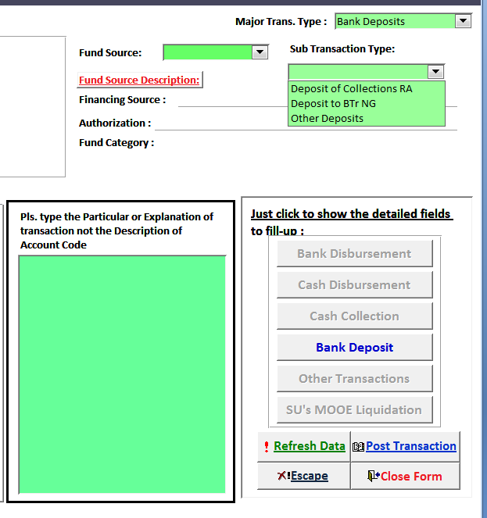
From the same RCD as the collection
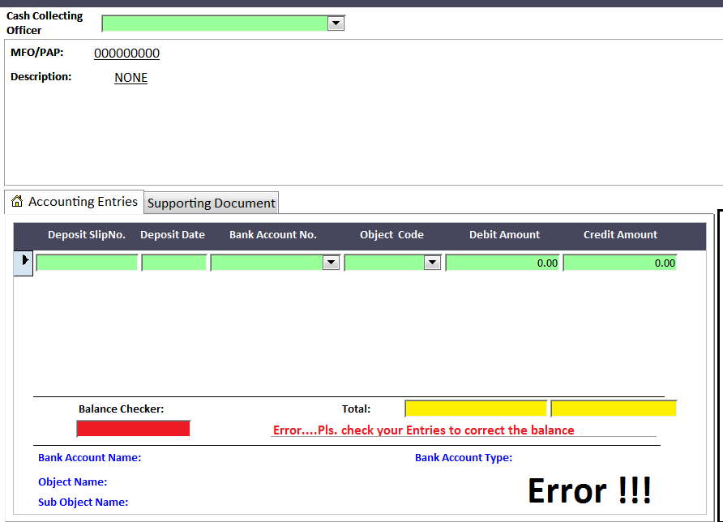
3

22
1

Information from the Deposit Slip
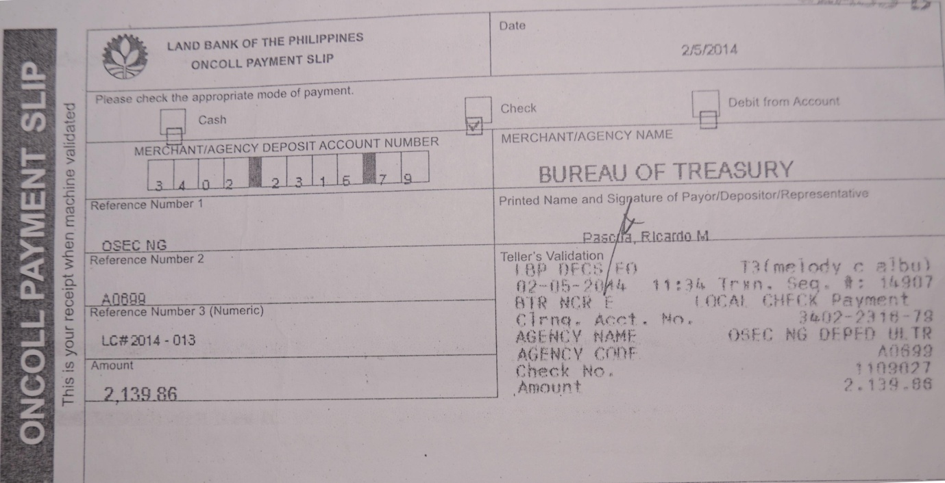
3

22
1
Deposit Slip No.
Deposit Date
Bank Account No.

Deposits of Collections
As a rule, all collections made by DepEd’s operating units will be deposited to the account of the department or the Treasurer of the Philippines daily or not later than the next banking day. All deposits must be evidenced by Deposit Slips (DS) and RCDs.
The illustrative accounting entries for some related transactions are as follows:
Transaction and Accounting Entries | Fund Source Code | MFO/PAP Code | Object Code | Debit | Credit
Cash – Agency/Agency Deposit, Regular  Cash – Collecting Officer  Deposit of NG collections | 101101  101101 | 000000000  000000000 | 1010401000  1010101000 | x,xxx.xx | x,xxx.xx
Cash – Agency/Agency Deposit, Trust  Cash – Collecting Officer  Deposit of Trust NG collections | 101101  101101 | 000000000  000000000 | 1010403000  1010101000 | x,xxx.xx | x,xxx.xx
Cash in Bank – LCCA  Cash – Collecting Officer  Deposit of Revolving Funds collections in DBP accounts | 207512  207512 | 000000000  000000000 | 1010202016  1010101000 | x,xxx.xx | x,xxx.xx
Cash in Bank – LCCA  Cash – Collecting Officer  Deposit of Trust receipts in LBP accounts | 101101  101101 | 000000000  000000000 | 1010202024  1010101000 | x,xxx.xx | x,xxx.xx
Cash in Bank – LCCA  Cash – Collecting Officer  Deposit of Provident Fund in PVB accounts | 308602  308602 | 000000000  000000000 | 1010202032  1010101000 | x,xxx.xx | x,xxx.xx

Trust Fund
Trust Fund is a fund which accounts for the receipts by any DepEd operating unit or by a public officer acting as trustee, agent, or administrator for the fulfilment of some obligations. Receipted trust fund collections will fall under deposits of collections as illustrated above. For trust receipts that will not course through a collection and credited directly to the required bank account, depending on the trust agreement, the recording of transaction must base on that signed trust agreement and bank advice.
The illustrative accounting entries for some related transactions are as follows:
Transaction and Accounting Entries | Fund Source Code | MFO/PAP Code | Object Code | Debit | Credit
Cash in Bank – LCCA  Trust Liabilities  Receipt of Trust Funds in the LBP accounts | 101101  101101 | 000000000  000000000 | 1010202024  2040101000 | x,xxx.xx | x,xxx.xx

Adjustment to Bank Deposits
There are instances that checks received by Collecting Officers in payment of taxes, fees and other debts due to the government are dishonored by the drawee banks. A check is said to be dishonored by non-payment when, upon its being duly presented for payment, such payment is refused or cannot be obtained. (Sec. 83, RA No. 2031, Negotiable Instrument Law). It may also be defined as those checks paid to the agency, which were dishonored by the AGDB due to Drawn Against Insufficient Fund or Drawn Against Uncleared Deposits.
The following documents shall support the collection:
- Dishonored check
- Report of Collections and Deposits
- Reference Deposit Slip
The illustrative accounting entries for some related transactions are as follows:
Transaction and Accounting Entries | Fund Source Code | MFO/PAP Code | Object Code | Debit | Credit
Cash – Collecting Officer  Cash – Treasury/Agency Deposit, Regular  Return of dishonoured check | 101101  101101 | 000000000  000000000 | 1010101000  1010401000 | x,xxx.xx | x,xxx.xx

Other Transactions

Overview of Other Transactions
Other Transactions refer to all types of financial transactions that cannot be categorized by any of the identified types of transactions above. Non-cash transactions normally fall under this category, such as but not limited to the following:
- NCA and/or NTA Receipts and its Lapsing
- Remittances to the Bureau of Internal Revenue (BIR) through a Tax Remittance Advice (TRA)
- Non-cash expenses, including the Supplies and Materials issued and used, Impairment Losses, Depreciation Expenses, and the like
- Correction or adjusting entries
- Mid-year or Year-end closing of nominal accounts

NCA/NTA Receipt
A MDS is a procedure whereby the disbursements by the government agencies, chargeable against the account of the Treasurer of the Philippines, are effected through the AGSB. It is evidenced by an authorization, the NCA, issued by the DBM to DepEd’s operating units, to withdraw cash from the National Treasury through the issuance of MDS checks. This is the cash authority granted to CO, ROs, DOs, and IUs through the AGSBs of the MDS. Currently, the MDS is being serviced by the Lank Bank of the Philippines (LBP), Development Bank of the Philippines (DBP) and Philippine Veterans Bank (PVB).
The amount indicated in the NCA is considered a bank deposit. Such will be recorded in the books of accounts, to be supported by the Advice of Notice of Cash Allocation Issued (ANCAI).
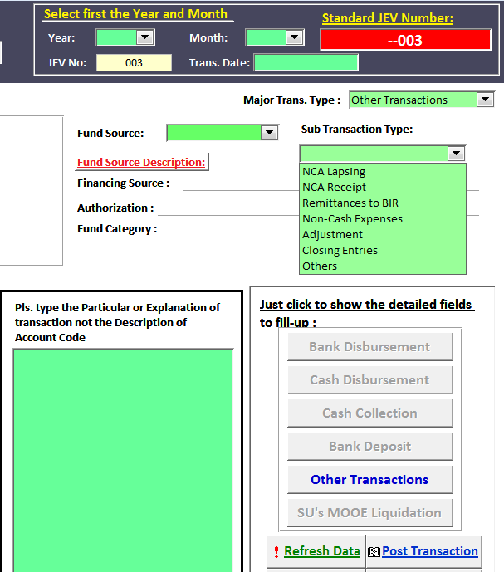
Based on the NCA or Sub-ARO/NTA

The illustrative accounting entries for some related transactions are as follows:
Transaction and Accounting Entries | Fund Source Code | MFO/PAP Code | Object Code | Debit | Credit
Cash – MDS, Regular  Subsidy from National Government  Receipt of NCA | 101101  101101 | 000000000  000000000 | 1010404000  4030101000 | x,xxx.xx | x,xxx.xx
Notice of Transfer of Allocation (NTA) is a scheme whereby DepEd shall instruct their MDS-AGSB to transfer a specific amount out of their NCA available book balance to the MDS accounts of the LLOU within the same department, receiving NCA directly from the DBM. The individual MDS-AGSB of the recipient NGA shall be the same MDS-AGSB as that used by the transferring NGA.
In the case of the receiving NGA, the amount indicated in the NTA is considered a bank deposit. Such will be recorded in the books of accounts, to be supported by approved copy of NTA.
Transaction and Accounting Entries | Fund Source Code | MFO/PAP Code | Object Code | Debit | Credit
Cash – MDS, Regular  Subsidy from Other NGAs  Receipt of NCA | 101101  101101 | 000000000  000000000 | 1010404000  4030102000 | x,xxx.xx | x,xxx.xx
The illustrative accounting entries for some related transactions are as follows:

To record the above transactions using the eFRS, the following steps must be observed:

- Set the JEV Number by choosing the appropriate year and month of the transaction, then the transaction date.

- Click and select the transaction category, “Other Transactions”, from the dropdown list. Make sure to click the same “Other Transactions” button for the correct form of entry fields to appear.

- There are several sub-transaction types, so click and select the sub-transaction type “NCA/NTA Receipts”.

- Choose the appropriate Fund Source Code from the dropdown lists based on the code indicated in the NCA or Sub-ARO/NTA.

- Input the Bank Account Number and type the Particulars in the appropriate fields.

- Complete the accounting entries: Choose the zeroes or None for MFO/PAP Code, the appropriate Object Code, and supply the debit and credit amounts based on the NCA/NTA receipt.
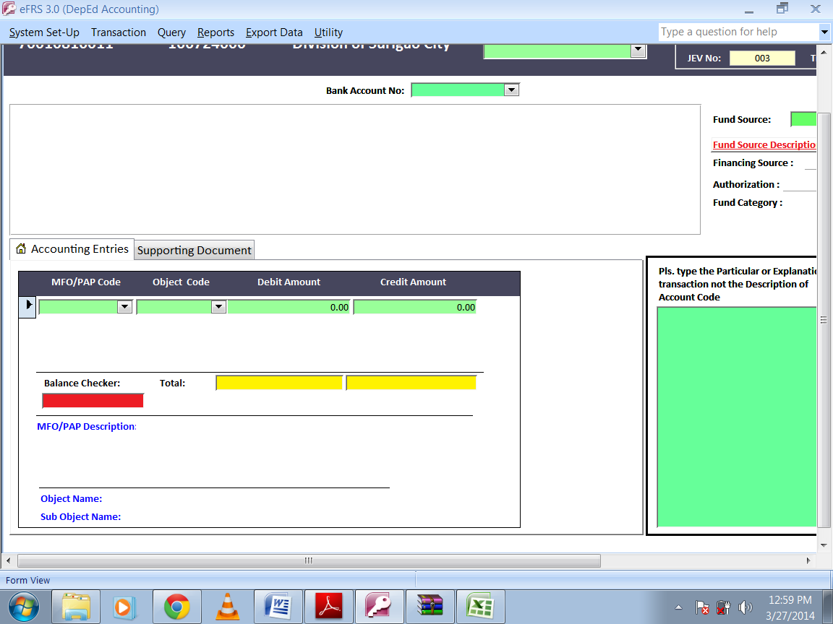

- Verify the debit and credit entries before clicking the “Post Transaction” button. Descriptions for each entry level are reflected at the bottom of the display page. Make sure that the balance checker shows zero amounts and no ERRORS.

- When necessary, print the JEV and file on top of the transaction documentation.
Sample information from a NCA
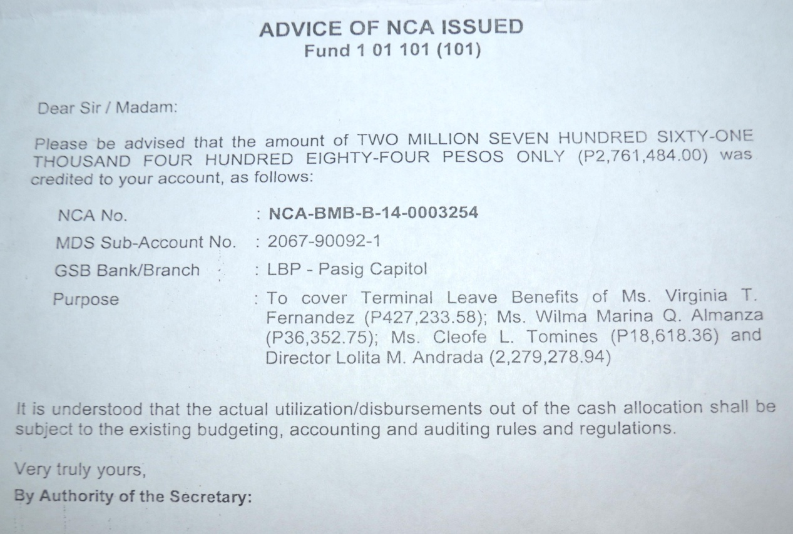
Fund Source Code

Remittances to BIR
For all NGAs, like DepEd, performing as a withholding agent, the remittance of taxes withheld to the BIR is done regularly through issuance of Tax Remittance Advice (TRA). TRA is the “constructive payment” document which agencies issue/file with the BIR to report and record remittances of all taxes withheld from various transactions. This serves as basis for BIR and BTr to record as income, the tax collection and deposit in their books of accounts.

The following documents shall support the remittance:
- TRA
- BIR Forms (1600, 1601C, 1601E, etc.)

The accounting entries for some related transactions are as follows:
Transaction and Accounting Entries | Fund Source Code | MFO/PAP Code | Object Code | Debit | Credit
Due to BIR  Subsidy from National Government  BIR remittances thru TRA | 101101  101101 | 000000000  000000000 | 2020101000  4030101000 | x,xxx.xx | x,xxx.xx

Recording remittances in the eFRS shall follow the same steps as NCA Receipt, except for the sub-transaction type which will be “Remittances to BIR” and the absence of Bank Account No. See below the illustrations for more guidance.

Information from TRA
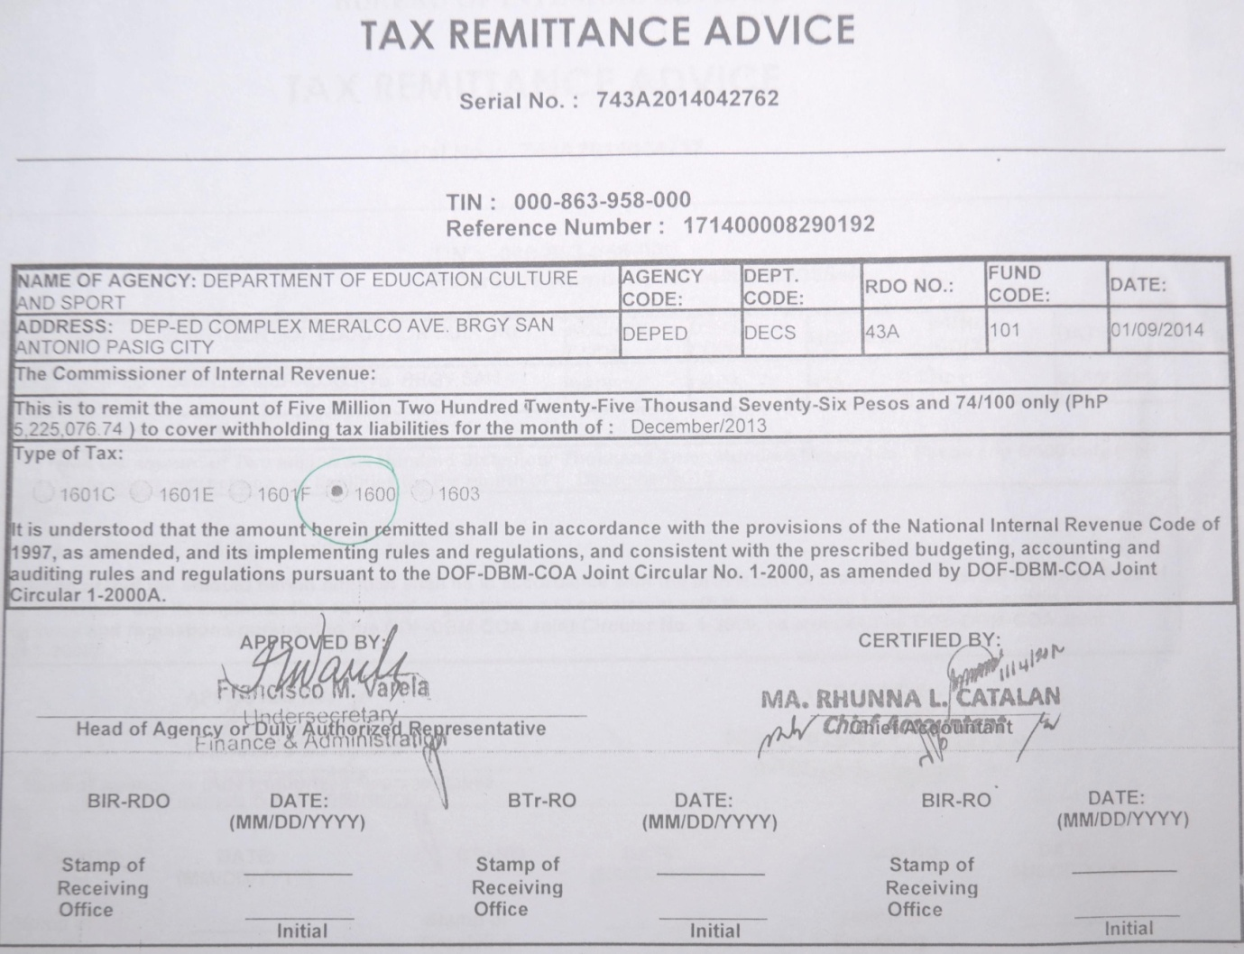
Required input fields
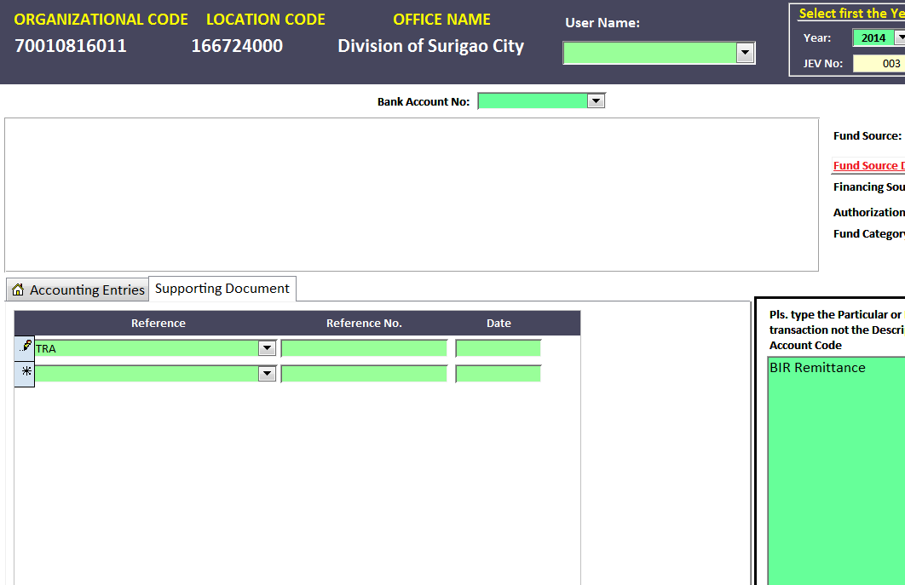
Information from TRA

Non-Cash Expenses
Impairment Losses
The impairment of assets, such as Investments, Receivables, Inventories, Property, Plant and Equipment, and Other Assets, seeks to ensure that these assets are not carried at more than their recoverable amount (i.e. the higher of fair value less costs of disposal and value in use).
An impairment loss is a type of one-time or nonrecurring charge that is entered into the accounting records as a means of correcting the value of an asset that has an overstated book value. The idea is to reduce that book value down to what is considered a fair value, allowing for whatever factors have caused the change in the worth of that asset. From this perspective, impairment losses can be seen as accounting procedures that help to create a more balanced and accurate assessment of the true and current value of any assets held by DepEd.
The accounting treatment and support documentation for the recognition of impairment loss shall be dependent on the COA guidelines, as this is newly introduced in the Revised Chart of Accounts (COA Circular No. 2013-002).

To recording the transaction in the eFRS, follow the same steps as NCA Receipt, except for the sub-transaction type which will be “Remittances to BIR” and the absence of Bank Account No. See below the illustrations for more guidance.

Since Bad Debts Expense is replaced by Impairment Loss – Loans and Receivables, the Aging of Receivables may support the recognition. The illustrative accounting entries are as follows:
Transaction and Accounting Entries | Fund Source Code | MFO/PAP Code | Object Code | Debit | Credit
Impairment Loss – Accounts Receivable  Allowance for Impairment – AR  Provision for impairment losses | 101101  101101 | 000000000  000000000 | 5050302000  1030101100 | x,xxx.xx | x,xxx.xx
Depreciation for Property, Plant and Equipment
The costs of property, plant and equipment are allocated to the periods benefited through the provision of accumulated depreciation. Depreciation is the systematic and gradual allocation of the depreciable amount of asset over its useful life.
Other than the provision for impairment losses, the periodic allocation of cost for the wear and tear of all Property, Plant and Equipment the Aging of Receivables will also be recognized based on the Schedule of Depreciation. The illustrative accounting entries are as follows:
Transaction and Accounting Entries | Fund Source Code | MFO/PAP Code | Object Code | Debit | Credit
Depreciation – Buildings  Depreciation – School Building  Depreciation – Hostels and Dormitories  Depreciation – Office Equipment  Depreciation – ICT Equipment  Depreciation – Motor Vehicles  Depreciation – Furniture and Fixtures  Depreciation – Books  Accu. Depreciation – Buildings  Accu. Depreciation – School Building  Accu. Dep’n – Hostels and Dormitories  Accu. Depreciation – Office Equipment  Accu. Depreciation – ICT Equipment  Accu. Depreciation – Motor Vehicles  Accu. Dep’n – Furniture and Fixtures  Accu. Depreciation – Books  Provision for depreciation of the year | 101101  101101  101101  101101  101101  101101  101101  101101  101101  101101  101101  101101  101101  101101  101101  101101 | 100010000  302050003  100010000  100010000  302050002  100010000  302050003  302050002  000000000  000000000  000000000  000000000  000000000  000000000  000000000  000000000 | 5050104001  5050104002  5050104006  5050105002  5050105003  5050106001  5050107001  5050107002  1060401100  1060402100  1060406100  1060502100  1060503100  1060601100  1060701100  1060702100 | x,xxx.xx  x,xxx.xx  x,xxx.xx  x,xxx.xx  x,xxx.xx  x,xxx.xx  x,xxx.xx  x,xxx.xx | x,xxx.xx  x,xxx.xx  x,xxx.xx  x,xxx.xx  x,xxx.xx  x,xxx.xx  x,xxx.xx  x,xxx.xx

General Corrections/Adjustments
Accounting for Disallowances
Disallowances shall be taken up in the books of accounts only when they become final and executory. It will be accounted for as an Expense if it pertains to the current year or as an adjustment to the Government Equity account if pertaining to expenses of prior years.
Based on the approved Notice of Disallowances from COA, the recording and entry to eFRS shall follow the illustrations and accounting entries below:
To recording the transaction in the eFRS, follow the same steps as NCA Receipt, except for the sub-transaction type which will be “Remittances to BIR” and the absence of Bank Account No. See below the illustrations for more guidance.
The illustrative accounting entries are as follows:
Transaction and Accounting Entries | Fund Source Code | MFO/PAP Code | Object Code | Debit | Credit
Impairment Loss – Accounts Receivable  Allowance for Impairment – AR  Provision for impairment losses | 101101  101101 | 000000000  000000000 | 5050302000  1030101100 | x,xxx.xx | x,xxx.xx
Accrued and Deferred Items
Under the matching principle, adjustments shall be made for economic activities that have taken place but are not yet recorded at the time when the financial statements are prepared. Such adjusting journal entries are made to ensure that revenues and expenses are recorded in the period when they are earned or incurred.
Common transactions under this category are Supplies and Materials Issued and other prepayments. Completion, acceptance and turn-over of constructed Property, Plant and Equipment also require adjustments.
The supporting documents required are the following:
- Report of Supplies and Materials Issued from the Property and Supply Unit
- Certificate of Completion
- Certificate of Turn-over and Acceptance
- Lease Agreement
The illustrative accounting entries are as follows:
Transaction and Accounting Entries | Fund Source Code | MFO/PAP Code | Object Code | Debit | Credit
Office Supplies Expense  Office Supplies Inventory  Record expense portion | 101101  101101 | 100010000  000000000 | 5020301000  1040401000 | x,xxx.xx | x,xxx.xx
Rent/Lease Expense  Prepaid Rent  Record expense portion | 101101  101101 | 100010000  000000000 | 5029905000  1990202000 | x,xxx.xx | x,xxx.xx
School Buildings  Construction in Progress – Buildings & Other Structures  Record completed, turned over and accepted PPE. | 101101  101101 | 000000000  000000000 | 1060402000  1061003000 | x,xxx.xx | x,xxx.xx

NCA/NTA Lapsing
Starting January 1, 2014, pursuant to the DBM Circular Letter 2013-16, the NCAs for crediting to National Government Agency (NGA)’s regular Modified Disbursement System sub-accounts for any given quarter shall be valid until the last working day of the 3rd month of that quarter. Thus, the difference between the NCA and the Report of Check Issued (RCI) and ADA shall be considered lapsed automatically.
NTA will also lapse along with the NCA lapsing period. When NTA is issued out of the MDS Trust account, the allocation will lapse at the end of the year.
The necessary reference documents to support the recording of bank disbursement transactions are the following:
- NTA or Copy of check issued
- DV
- OBr
Illustrative accounting entries for some related transactions are as follows:
Transaction and Accounting Entries | Fund Source Code | MFO/PAP Code | Object Code | Debit | Credit
Subsidy from National Government  Cash – MDS, Regular  Lapsing of NCA | 101101  101101 | 000000000  000000000 | 4030101000  1010404000 | x,xxx.xx | x,xxx.xx
Subsidy from Other NGAs  Cash – MDS, Regular  Lapsing of NTA | 101101  101101 | 000000000  000000000 | 4030102000  1010404000 | x,xxx.xx | x,xxx.xx

Year-end Closing
Closing journal entries are general journal entries which close out the balances of all nominal/ temporary and intermediate accounts at the end of the accounting period. The nominal and intermediate accounts that shall be closed at the end of the accounting period are as follows:
The illustrative accounting entries are as follows:
Transaction and Accounting Entries | Fund Source Code | MFO/PAP Code | Object Code | Debit | Credit
Subsidy from National Government  Subsidy from Other NGAs  School Fees  Seminar/Training Fees  Rent/Lease Income  Income from Hostels/Dormitories  Income from Printing and Publication  Interest Income  Other Business Income  Income and Expense Summary  Close income accounts | 101101  101101  101101  101101  101101  101101  101101  101101  101101  101101 | 000000000  000000000  000000000  000000000  000000000  000000000  000000000  000000000  000000000  000000000 | 4030101000  4030102000  4020201000  4020204000  4020205000  4020213000  4020215000  4020221000  4020299000  3030101000 | x,xxx.xx  x,xxx.xx  x,xxx.xx  x,xxx.xx  x,xxx.xx  x,xxx.xx  x,xxx.xx  x,xxx.xx  x,xxx.xx | x,xxx.xx
Income and Expense Summary  Salaries and Wages - Regular  PERA  Retirement and Life Insurance Premiums  Pag-IBIG Contributions  PhilHealth Contributions  Employees Comp Insurance Premiums  Traveling Expense – Local  Training Expense  Office Supplies Expenses  Fuel, Oil and Lubricants Expenses  Other Supplies and Materials Expenses  Electricity Expenses  Postage and Courier Services  Telephone Expenses  Internet Subscription Expenses  Janitorial Services  Security Services  Financial Assistance to NGAs  Bank Charges  Depreciation – Buildings  Depreciation – School Building  Depreciation – Hostels and Dormitories  Depreciation – Office Equipment  Depreciation – ICT Equipment  Depreciation – Motor Vehicles  Depreciation – Furniture and Fixtures  Depreciation – Books  Impairment Loss – Accounts Receivable  Close expense accounts | 101101  101101  101101  101101  101101  101101  101101  101101  101101  101101  101101  101101  101101  101101  101101  101101  101101  101101  101101  101101  101101  101101  101101  101101  101101  101101  101101  101101  101101  101101 | 000000000  000000000  000000000  000000000  000000000  000000000  000000000  000000000  000000000  000000000  000000000  000000000  000000000  000000000  000000000  000000000  000000000  000000000  000000000  000000000  000000000  000000000  000000000  000000000  000000000  000000000  000000000  000000000  000000000  000000000 | 3030101000  5010101001  5010201000  5010301000  5010302000  5010303000  5010304000  5020101000  5020201000  5020301000  5020309000  5020399000  5020502000  5020401000  5020402000  5020403000  5021202000  5021203000  5021402000  5030104000  5050104001  5050104002  5050104006  5050105002  5050105003  5050106001  5050107001  5050107002  5050302000 | x,xxx.xx | x,xxx.xx  x,xxx.xx  x,xxx.xx  x,xxx.xx  x,xxx.xx  x,xxx.xx  x,xxx.xx  x,xxx.xx  x,xxx.xx  x,xxx.xx  x,xxx.xx  x,xxx.xx  x,xxx.xx  x,xxx.xx  x,xxx.xx  x,xxx.xx  x,xxx.xx  x,xxx.xx  x,xxx.xx  x,xxx.xx  x,xxx.xx  x,xxx.xx  x,xxx.xx  x,xxx.xx  x,xxx.xx  x,xxx.xx  x,xxx.xx  x,xxx.xx  x,xxx.xx
Registration Fees  Seminar/Training Fees  Rent/Lease Income  Income from Hostels/Dormitories  Interest Income  Other Business Income  Income and Expense Summary  Close income accounts of RELC | 207512  207512  207512  207512  207512  207512  207512 | 000000000  000000000  000000000  000000000  000000000  000000000  000000000 | 4020102000  4020204000  4020205000  4020213000  4020221000  4020299000  3030101000 | x,xxx.xx  x,xxx.xx  x,xxx.xx  x,xxx.xx  x,xxx.xx  x,xxx.xx | x,xxx.xx

SU’s MOOE Liquidation

Overview of MOOE Liquidation
Cash advances granted by Division Offices to their respective Spending Units covering budgetary releases for current operating expenses, Maintenance and Other Operating Expenses most particularly, shall be accounted for as "Advances for Operating Expenses" by the releasing agency. This shall be liquidated or settled before the subsequent advances will be granted.
This particular transaction type will only be used by the Division Office concerned.
To record the liquidation of cash advances for travel, special purpose, and operating expenses, the following documents shall support the expenditures:
- Liquidation Report
- Receipts/Invoices
- Original DV
- Original OBr
- Reference issued check
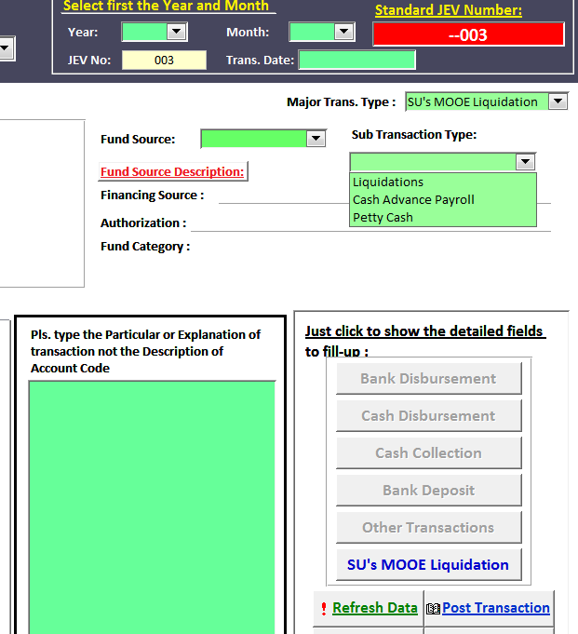

Using the eFRS, the following steps must be observed:

- Set the JEV Number by choosing the appropriate year and month of the transaction, then the transaction date.

- Click and select the transaction category, “SU’s MOOE Liquidation”, from the dropdown list. Make sure to click the same “SU’s MOOE Liquidation” button for the correct form of entry fields to appear.

- Click and select the sub-transaction type, whether purely “Liquidation”, “Cash Advance Payroll” or “Petty Cash”, and choose the appropriate Fund Source Code from the dropdown lists. The Fund Source code should be consistent with the code in the original OBr.

- Supply all JEV details, reference document number, amount of liquidations, and allotment class. Then click and select the Spending Unit’s Organization Code from the dropdown list.

Prepare 1 JEV for each Spending Unit (only for Secondary Schools) with own Organization Code based on the Liquidation Report submitted. SUs without assigned Organization Codes shall be accounted for using the DO proper’s Organization Code.

- Click and select the appropriate MFO/PAP Code for “MFO2: Operation of Schools – Secondary Schools”, i.e. 302050003, from the dropdown list in the Accounting entries section. The supply the appropriate Objects Codes and the corresponding amounts of both debit and credit entries.

- Verify the debit and credit entries before clicking the “Post Transaction” button. Descriptions for each entry level are reflected at the bottom of the display page. Make sure that the balance checker shows zero amounts and no ERRORS.

- When necessary, print the JEV and file on top of the transaction documentation.

Accounting Entries
The illustrative accounting entry when the cash advance for MOOE of spending units was granted is as follows:
Transaction and Accounting Entries | Fund Source Code | Org Code | MFO/PAP Code | Object Code | Debit | Credit
Advances for Operating Expenses  Cash – MDS, Regular  Grant of cash advance for SU’s MOOE | 101101  101101 | 070010813005  070010913072 | 000000000  000000000 | 1030501000  1010404000 | x,xxx.xx | x,xxx.xx

Required input fields
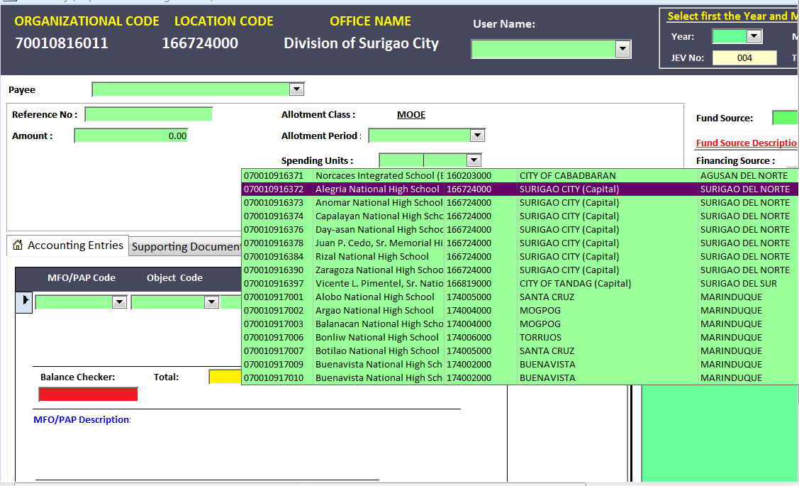
Information from the Liquidation Report

The illustrative accounting entries for the related liquidation of the cash advance for MOOE are as follows:
Transaction and Accounting Entries | Fund Source Code | Org Code | MFO/PAP Code | Object Code | Debit | Credit
Office Supplies Expenses  Electricity Expenses  Telephone Expenses  Janitorial Services  Security Services  Advances for Operating Expenses  Record SU’s MOOE liquidation | 101101  101101  101101  101101  101101  101101 | 070010913072  070010913072  070010913072  070010913072  070010913072  070010813005 | 302050002  302050002  302050002  302050002  302050002  000000000 | 5020301000  5020402000  5020502000  5021202000  5011203000  1990101000 | x,xxx.xx  x,xxx.xx  x,xxx.xx  x,xxx.xx  x,xxx.xx | x,xxx.xx

Frequently Asked Questions

- How to account for Prior Period Adjustments (PPA)?
As provided in the COA Circular No. 2013-002 on the Adoption of the Revised Chart of Accounts for National Government Agencies, the account Government Equity is described as the account to be used to record the cumulative results of normal and continuous operations of the agency including prior period adjustments, effects of changes in accounting policy and other capital adjustments. Suffice it to say that all PPA outstanding balances and those current transactions with similar treatments will be closed to the Government Equity account, unless otherwise specified by the COA.

- We account downloading of MOOE to non-IUs (SUs) as an outright expense. Is this acceptable?
Reporting the MOOE downloading as an outright expense, in the current account name of Financial Assistance to NGAs, may be acceptable. The downside though is that MOOE comes in different and several forms, e.g. Electricity expense, Water expense, Telephone expense, Repairs and Maintenance expense, etc., which are better recognized as individual expense items. Lumping them together in one subsidy account will compromise the fairness and integrity of the financial information. Downloading of MOOE to SUs would rather be treated as Advances for Operating Units which is subject to liquidation.

- Can we delete erroneous JEVs?
Erroneous JEV may be corrected through the Edit Data function. But basically, a JEV once posted can no longer be deleted. Prepare a separate, new JEV instead containing the reversing entry. Use the same data in the previous JEV, and input a negative amount in the JEV details section.

- Is MFO/PAP code needed to be indicated for every Object code (accounting entry level?
MFO/PAP Codes originate from the approved budget of the Department. Therefore the coding is important in monitoring budgetary items.

Approved budget contains expenditure items, i.e. PS, MOOE and CO. Therefore the MFO/PAP Codes must be appropriately indicated in expense item only, including PPEs. No such codes are provided for all other Assets, Liabilities, Incomes, Equity, and Non-Cash Expenses (let’s call them as ALIEN). Following the 5-segment, 46-digit UACS, “None” in the form of 9 zeroes (000000000) will be used to code ALIEN accounts.

- What about MFO/PAP code for non-budgetary items?
Given that MFO/PAP Codes are for budgetary items only and hence used for General Fund transactions. All receipts and disbursements for Revolving Funds, Trust Receipts such as Provident Funds, and other Off-Budgetary and Custodial Funds are coded 000000000 or None MFO/PAP.

- Is it necessary to complete the 5-segment, 46-digit UACS for each transaction?
Yes. The UACS is a multi-dimensional coding structure. Each digit in each segment code captures all the required and/or relevant information for all PFM users. Each provides a level of detail for every transaction, with hierarchies for grouping and consolidating information. Each segment can be used for one purpose only, and each purpose captured fully in that one segment. The FOLMO (Fund Source, Organization, Location, MFO/PAP, and Object codes) therefore must always be completely indicated in recording each financial transaction. Furthermore, complete UACS enables data for multiple uses, for whatever reporting purpose, and in whatever format or template.

